Connection Between Orthostatic Blood Pressure Dysregulation and Mental Health Issues in Adults: A Cross-Sectional Study
*Corresponding Author Email: katek2030@gmail.com
Abstract
BACKGROUND
Orthostatic hypotension (OH) is a cardiovascular condition marked by a significant drop in blood pressure upon standing. Recent studies indicate that mental health disorders may impact OH prevalence, though the nature of these associations is not fully understood. This study investigates the relationship between orthostatic blood pressure dysregulation and mental health disorders, including depression, anxiety, stress, and distress, in adults of Ndola City, Zambia.
METHODS
A cross-sectional study design was employed with adult participants. OH was assessed using standard orthostatic blood pressure measurement protocols, while mental health status was evaluated using validated scales. Chi-square tests were conducted to analyze associations between OH and mental health variables.
RESULTS
Results showed a strong association between depression and OH (p < 0.001, Cramér's V = 0.8831), with significant links also found between stress (p < 0.001, Cramér's V = 0.3220) and distress (p < 0.001, Cramér's V = 0.2046). However, no significant association was observed between anxiety and OH (p > 0.05, Cramér's V = -0.0480).
CONCLUSION
These findings emphasize the importance of considering mental health in evaluating and managing OH, particularly regarding depression, stress, and distress. A multidisciplinary approach is recommended to improve outcomes for individuals with co-occurring OH and mental health disorders.

KEYWORDS: Depression, anxiety, stress, distress, mental health, blood pressure dysregulation.
1. Background
Orthostatic blood pressure dysregulation, characterized by significant BP changes upon standing, is more prevalent in individuals with mental health disorders compared to the general population [1,2]. Mental health issues like depression, anxiety and stress are associated with physiological alterations, including autonomic dysfunction and cardiovascular changes, which can lead to orthostatic hypotension or hypertension [3,4,5,6].
1.2 Rationale
Orthostatic dysregulation can cause dizziness, fainting, falls, and increased cardiovascular morbidity and mortality [2,3]. For those with mental disorders, it may worsen symptoms and reduce quality of life [1,4]. However, research in this area remains limited, especially in developing countries [1].
This study aims to investigate the relationship between orthostatic dysregulation and specific mental disorders.
This study aims to:
Investigate the relationship between orthostatic dysregulation and specific mental health disorders (depression, anxiety, stress and distress)
2. Methods
2.1 Study Design and Setting
A cross-sectional study was conducted from September 2023 to June 2024 in Ndola City, Zambia, involving 770 participants categorized by age. Participants were recruited from various health centers, including Peter Singogo Police Clinic, Nkwazi Clinic, and several others, as well as from the MCS School of Medicine, ensuring a diverse representation of the urban and peri-urban population of Ndola [7,8].
2.2 Participants
The study included 770 adults from Ndola City, Zambia. Two sampling methods were employed: simple random sampling for medical students and purposive sampling for individuals from health centers and residential areas.
2.3 Simple Random Sampling
A complete list of medical students enrolled at CBU-MCS-SOM for the 2023-2024 academic year was used as the sampling frame. A random number generator was utilized to select students, ensuring equal chances of selection [8].
2.4 Purposive Sampling
Purposive sampling was employed for participants from health centers and residential areas, selecting individuals based on age, gender, and medical history.
2.5 Variables
Key variables assessed included age, orthostatic hypotension (OH), depression, anxiety, and stress.
Orthostatic Hypotension (OH)
Blood pressure was measured in both supine and upright positions [9].
Mental Health Assessments
Depression: Persistent sadness and lack of interest.
Anxiety: Excessive worry or fear.
Stress: The body's response to demanding situations.
Mental health was evaluated using the DASS-21 [10] and the General Health Questionnaire (GHQ-12), with higher scores indicating greater distress [11].
2.6 Data Collection
Data were collected through surveys using the DASS-21 and GHQ-12 questionnaires, alongside physiological measurements of blood pressure. Demographic data, including age and gender, were also recorded.
2.6.1 Ethics Statement
The protocol was approved by CBUREC, institutional ethics committee at MCS- School of Medicine at Copperbelt University, and certify that the study was performed in accordance with the ethical standards as laid down in the 1964 Declaration of Helsinki and its later amendments or comparable ethical standards.
2.7 Data Sources and Measurement
Blood pressure was measured using an aneroid sphygmomanometer [12]. The DASS-21 and GHQ-12 scales have established psychometric properties in the Zambian context, ensuring their appropriateness for this study [13,14,15].
2.8 Bias Minimization in the Study Design
The study utilized a cross-sectional design with 770 participants, employing validated measurement tools and standardized protocols to minimize bias. Participants were systematically sampled to ensure representation of the Ndola City population, which is approximately 550,000, focusing on young adults (ages 16-40) and middle-aged adults (ages 41-60). A confidence level of 95% and a margin of error of 5% were established, resulting in an equal distribution of 385 individuals from each age group.
A power analysis confirmed that the sample size of 770 provided a statistical power of 0.90 at a significance level of α = 0.05, ensuring reliable conclusions [16].
2.9 Quantitative Variables
Age was categorized into groups for analysis, and the prevalence of orthostatic hypotension (OH) and mental health scores were compared across these age groups.
2.10 Statistical Methods
To analyze the data, the following methods were employed:
Participant Categorization: Participants were grouped by age to examine age-related differences in OH and mental health outcomes.
Blood Pressure Measurement: Blood pressure was measured in both supine and standing positions to diagnose OH based on significant BP drops.
Mental Health Assessment: Mental health was evaluated using two validated instruments:
DASS-21: Measures severity of depression, anxiety, and stress.
GHQ-12: Assesses general mental health and well-being.
2.11 Statistical Analyses:
Pearson Chi-Square Tests: Examined relationships between categorical variables, such as age groups and OH prevalence.
Descriptive Statistics: Summarized participant demographics and prevalence rates.
Correlation Analysis: Explored relationships between continuous variables, including age and mental health scores.
Significance Level: A significance level of 0.05 was set for all tests, with p-values less than 0.05 indicating statistically significant associations.
Software Utilization: SPSS version 26 and STATA 16 were used for data analysis and interpretation.
2.12 Data Availability Statement
The datasets generated during and/or analyzed during the current study are available from the corresponding author on reasonable request.
3. Results

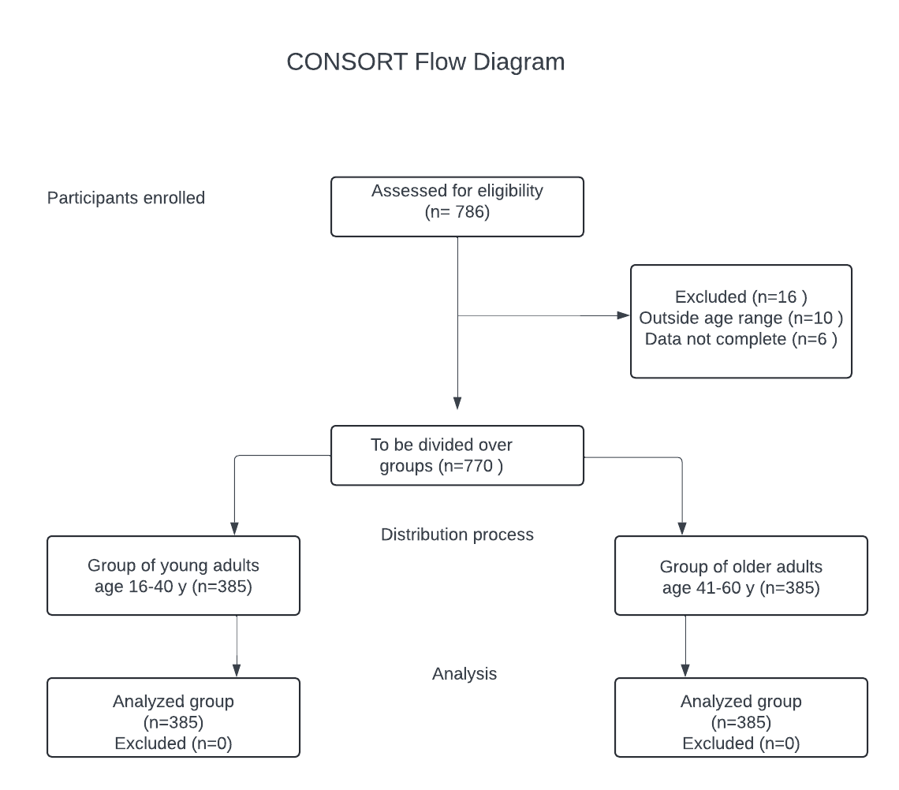
Fig 1 Study participants flow process

Results of the Tests and their Relation to Research Question:

Table 1 Grades of mental disorders and orthostatic hypotension
 |  | OH (%) | No OH (%) | Total (%)
Depression | Normal | 8 (13.8) | 565 (79.4) | 573 (74.4)
 | Mild | 3 (5.2) | 146 (20.5) | 149 (19.4)
 | Moderate | 47 (81) | 1 (0.1) | 48 (6.2)
Anxiety | Normal | 57 (98.3) | 670 (94.1) | 727 (94.4)
 | Mild | 1 (1.7) | 42 (5.9) | 43 (5.6)
 | Moderate | 0 | 0 | 0
Stress | Normal | 30 (51.7) | 643 (90.3) | 673 (87.4)
 | Mild | 27 (46.6) | 69 (9.7) | 96 (12.5)
 | Moderate | 1 (0.1) | 0 | 1 (1.7)
Distress | Normal | 39 (67.2) | 649 (91.2) | 688 (89.4)
 | Mild | 19 (32.8) | 63 (8.8) | 82 (10.6)

Table 1 presents the relationship between orthostatic hypotension (OH) and depression levels among study participants. The findings indicate a significantly higher prevalence of OH in individuals with moderate depression, with 81.0% of those with OH experiencing moderate depression compared to only 0.1% of those without OH. Specifically, 97.9% of participants with moderate depression had OH (47 out of 48), while only 1.4% of those with normal depression levels had OH (8 out of 573).
Regarding anxiety, most participants, regardless of OH status, exhibited normal levels. However, mild anxiety was more prevalent among those without OH (5.9%) compared to those with OH (1.7%). A majority of participants without OH had normal stress levels (90.3%), whereas only 51.7% of those with OH did. Mild stress was more common among participants with OH (46.6%) than those without (9.7%), and moderate stress was rare, observed in only one participant with OH. Additionally, 91.2% of participants without OH had normal distress levels (score <15), compared to 67.2% of those with OH. Participants with OH were more likely to experience distress scores >15 (32.8%) than those without OH (8.8%).

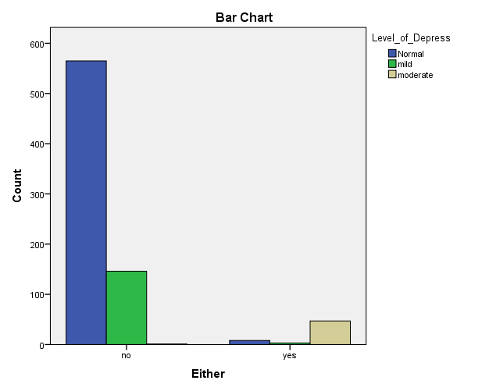
Fig 2 Depression level and orthostatic hypotension

The above bar chart compares the two variables of OH recording (yes/no) and depression levels among all subjects. This suggests a strong association between moderate depression and the presence of OH, whereas normal and mild depression levels are more prevalent in those without OH.

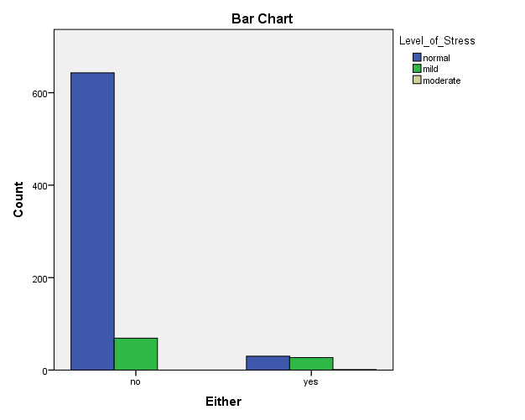
Fig 3 Stress level and orthostatic hypotension

The above bar chart compares the two variables of OH recording (yes/no) and stress levels among all subjects. Participants with orthostatic hypotension are more likely to experience mild stress compared to those without. The presence of moderate stress in participants with OH, albeit minimal, further indicates that OH might be associated with higher stress levels.

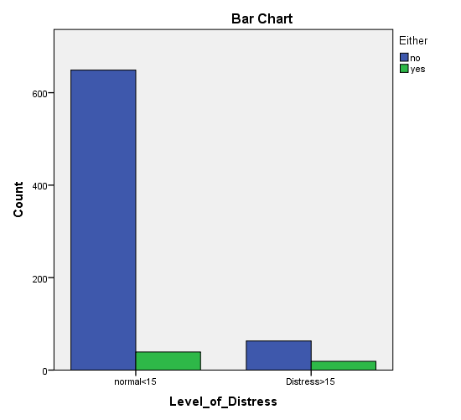
Fig 4 Depression grades and orthostatic hypotension

The bar graph in figure 4, presents a clear comparison of distress levels among participants with and without orthostatic hypotension (OH). This highlights a notable difference in distress levels between the two groups, indicating that individuals with orthostatic hypotension are more prone to experiencing higher levels of distress compared to those without the condition. The bar graph effectively illustrates these disparities, emphasizing the impact of orthostatic hypotension on emotional well-being.

Table 2 Chi square test for depression and orthostatic hypotension
Value Significance
Pearson chi2(2) = 600.4821 Pr = 0.000
likelihood-ratio chi2(2) = 288.1636 Pr = 0
Cramér's V = 0.8831
Fisher's exact = 0
The highly significant p-values (< 0.001) for both Pearson's chi-square and likelihood-ratio chi-square tests indicate a statistically significant association between depression grade and orthostatic hypotension (OH). Fisher's exact test (p = 0.000) further confirms this relationship. The Cramér's V statistic of 0.8831, very close to 1, suggests a very strong association between depression grade and OH prevalence.

Table 3 Chi square test for stress and orthostatic hypotension
Value Significance
Pearson chi2(2) = 79.8585 Pr = 0.000
likelihood-ratio chi2(2) = 52.1388 Pr = 0
Cramér's V = 0.322
Fisher's exact = 0
The chi-square test results show a highly significant association (p < 0.001) between stress grade and orthostatic hypotension (OH), with a chi-square value of 79.8585 and 2 degrees of freedom. The likelihood-ratio chi-square test (p = 0.000) and Cramér's V statistic of 0.3220 indicate a moderate strength of association between the variables. Fisher's exact test (p = 0.000) further confirms the significant relationship, providing robust evidence of the association between stress grade and OH prevalence.
Table 4 Chi square test for distress and orthostatic hypotension
Value Significance
Pearson chi2(1) = 32.2231 Pr = 0.000
likelihood-ratio chi2(1) = 23.0848 Pr = 0
Cramér's V = 0.2046
Fisher's exact = 0
1-sided Fisher's exact = 0
The highly significant Pearson's chi-square (p < 0.001) and likelihood-ratio chi-square (p = 0.000) values indicate a strong association between distress grades and orthostatic hypotension (OH). Cramér's V of 0.2046 suggests a moderate strength of association between these variables. Fisher's exact test (p = 0.000) further confirms the significant relationship, providing robust evidence of the association between distress grades and OH prevalence.

4. Discussion
The study results reveal a striking association between the presence of moderate depression and the occurrence of orthostatic hypotension (OH) among the adult population. The data (Table 1&2) show that 81.0% of participants with OH had moderate depression, while only 0.1% of those without OH had moderate depression. Furthermore, the prevalence of OH was remarkably high (97.9%) among individuals with moderate depression, compared to just 1.4% among those with normal levels of depression. These findings align with previous research that has identified a strong link between depression and OH. A systematic review and meta-analysis by Vloet et al, [17] found that depression was a significant risk factor for OH, with depressed individuals being more than twice as likely to experience OH compared to non-depressed individuals. Similarly, a study by Shibao et al, [18] reported that depression was associated with a higher risk of OH-related hospitalizations. The underlying mechanisms behind the association between depression and OH are not fully understood, but may involve dysregulation of the autonomic nervous system, impaired baroreceptor sensitivity, and reduced blood volume [17,18]. Depression has been shown to be linked with reduced heart rate variability, which is a marker of autonomic dysfunction and may contribute to the development of OH. The high prevalence of OH among individuals with moderate depression (Table 2) underscores the importance of screening for and managing OH in this population. Clinicians should be vigilant in assessing for OH in patients presenting with significant depressive symptoms, as the two conditions appear to be closely linked in this context. Appropriate interventions, such as lifestyle modifications, medication adjustments, and treatment of the underlying depression, may help to prevent or manage OH in this high-risk group [17, 18]. These findings highlight the need for a comprehensive, multidisciplinary approach to addressing the co-occurrence of OH and depression in the adult population of the community and similar settings. By recognizing the strong association between these two conditions, healthcare providers can better identify and manage individuals at risk, ultimately improving the overall health and well-being of the community.
Further research, including longitudinal studies and cross-cultural comparisons, may help elucidate the complex relationship between anxiety and OH in diverse populations.
The crosstabulation analysis (Table 3) reveals a difference in stress levels between participants with and without orthostatic hypotension (OH). Majority of participants without OH (90.3%) exhibit normal stress levels, this proportion is significantly lower among those with OH (51.7%). Mild stress levels are more prevalent among participants with OH (46.6%) compared to those without (9.7%). Moderate stress, although rare overall, is observed in only one participant with OH. Findings align with previous research that has identified a link between stress and OH. A study by Shibao et al [18], found that stress-related disorders were associated with an increased risk of OH-related hospitalizations in the United States. Similarly, Vloet et al [17], reported that stress was a significant risk factor for OH, particularly in the elderly population.
The underlying mechanisms linking stress and OH are not fully understood, but might involve dysregulation of the autonomic nervous system, impaired baroreceptor sensitivity, and reduced blood volume [17,18]. Stress was shown to be associated with increased sympathetic activity and reduced parasympathetic activity, which can contribute to the development of OH [18]. The higher prevalence of mild and moderate stress among participants with OH suggests that stress may be a critical factor in understanding the epidemiology of OH. Clinicians should be aware of this association and consider assessing stress levels in patients presenting with OH symptoms. Appropriate interventions, of stress management techniques, may help to prevent or manage OH in this high-risk group [17,18]. These findings highlight the need for a comprehensive approach to addressing OH in the adult population and similar settings. By recognizing the potential role of stress in the development of OH, healthcare providers can identify and manage individuals at risk, thus improving the overall health and well-being of the community.
The crosstabulation analysis (Table 4) reveals a significant difference in distress levels between participants with and without orthostatic hypotension (OH). Majority of participants without OH (91.2%) exhibit normal distress levels (<15), this proportion is lower among those with OH (67.2%). Participants with OH are more likely to experience distress (>15) at 32.8%, compared to only 8.8% of those without OH. These findings align with previous research that has identified a link between psychological distress and OH. A study by Shibao et al [18], found that mental health disorders, including distress, were associated with an increased risk of OH-related hospitalizations in the United States. Similarly, Vloet et al [17], reported that psychological factors, of stress and anxiety, were significant risk factors for OH, particularly in the elderly population. The underlying mechanisms linking distress and OH are not fully understood, but involve dysregulation of the autonomic nervous system, impaired baroreceptor sensitivity, and reduced blood volume [17,18]. Psychological distress has been shown to be associated with increased sympathetic activity and reduced parasympathetic activity, can contribute to the development of OH [18].
5. Conclusion
The study investigated the prevalence of orthostatic hypotension (OH) among individuals with mental health disorders in Ndola City, Zambia, revealing a strong association between moderate depression and OH, with 81% of participants with OH also experiencing moderate depression. In contrast, anxiety levels did not significantly differ between those with and without OH, indicating that anxiety may not be a major contributor to OH in this context. Higher levels of stress and psychological distress were significantly associated with OH, suggesting these factors may play a role in its occurrence.
Implications
The findings highlight pivotal part of screening and managing orthostatic hypotension (OH) in patients with depression and stress, advocating for a multidisciplinary approach to address related risk factors. Anxiety has been associated with OH in other contexts, it may not significantly impact OH prevalence in Ndola City. Clinicians must assess stress levels in patients with OH symptoms and implement stress management interventions. Further research and longitudinal studies, needed to better understand the complex relationships between mental health factors and OH across diverse populations.
Limitations
The cross-sectional design restricts the ability to establish causal relationships, as data were collected at a single point in time. Reliance on self-reported mental health assessments, although validated, might introduced bias due to subjective symptom interpretation. The exclusion of individuals with known cardiovascular diseases and those on antihypertensive medications may limit the generalizability of the findings to the broader population of individuals having mental health disorders.
Declaration of Patient Consent
The authors confirm that all appropriate patient consent was obtained.
Financial Support and Sponsorship
There was no financial support or sponsorship for this study.
Ethical Consideration
Approval to conduct research obtained from Research ethic committee
Bibliography
- Roca F, Rougette K, Zmuda L, et al. Association between orthostatic blood pressure dysregulation and geriatric syndromes: a cross-sectional study. BMC Geriatr. 2022;22:157. https://doi.org/10.1186/s12877-022-02844-8
- Mol A, Bui Hoang PTS, Sharmin S, et al. Orthostatic Hypotension and Falls in Older Adults: A Systematic Review and Meta-analysis. J Am Med Dir Assoc. 2019;20:589-597.e5.
- Ricci F, Fedorowski A, Radico F, et al. Cardiovascular morbidity and mortality related to orthostatic hypotension: a meta-analysis of prospective observational studies. Eur Heart J. 2015;36:1609-1617.
- Briggs R, Carey D, Kennelly SP, Kenny RA. Longitudinal Association Between Orthostatic Hypotension at 30 Seconds Post-Standing and Late-Life Depression. Hypertension. 2018;71:946-954.
- Min M, Shi T, Sun C, et al. The association between orthostatic hypotension and dementia: A meta-analysis of prospective cohort studies. Int J Geriatr Psychiatry. 2018;33:1541-1547.
- Kostis WJ, Sargsyan D, Mekkaoui C, et al. Association of orthostatic hypertension with mortality in the Systolic Hypertension in the Elderly Program. J Hum Hypertens. 2019;33:735-740.
- Polit, D. F., & Beck, C. T. Nursing research: Generating and assessing evidence for nursing practice (10th ed.). Lippincott Williams & Wilkins, 2021.
- Creswell, J. W., & Creswell, J. D. Research design: Qualitative, quantitative, and mixed methods approaches (5th ed.). SAGE Publications, 2017.
- Gibbons RJ, Balady GJ. Exercise as a therapeutic intervention: An overview. Am J Med. 2002;112:1-7. https://doi.org/10.1016/S0002-9343(02)01160-0
- American Psychiatric Association. Diagnostic and statistical manual of mental disorders (5th ed.). Arlington, VA: American Psychiatric Publishing, 2013.
- Goldberg, D. P., & Williams, P. A user's guide to the General Health Questionnaire. Windsor, UK: NFER-Nelson, 1988.
- Picone DS, Schultz MG, Otahal P, Aakhus S, Al-Jumaily AM, Black JA, et al. Accuracy of cuff-measured blood pressure: systematic reviews and meta-analyses. J Am Coll Cardiol. 2017;70:572-586. https://doi.org/10.1016/j.jacc.2017.05.030
- Daza P, Novy DM, Stanley MA, Averill P. The Depression Anxiety Stress Scale-21: Spanish translation and validation with a Hispanic sample. J Psychopathol Behav Assess. 2002;24:195-205.
- Antony MM, Bieling PJ, Cox BJ, Enns MW, Swinson RP. Psychometric properties of the 42-item and 21-item versions of the Depression Anxiety Stress Scales in clinical groups and a community sample. Psychol Assess. 1998;10:176-181.
- Borsa JC, Damásio BF, Bandeira DR. Adaptação e validação de instrumentos psicológicos entre culturas: algumas considerações. Paidéia (Ribeirão Preto). 2012;22:423-432.
- Faul F, Erdfelder E, Buchner A, Lang AG. Statistical power analyses using G*Power 3.1: Tests for correlation and regression analyses. Behav Res Methods. 2009;41:1149-1160. doi:10.3758/BRM.41.4.1149
- Vloet LC, Pel-Little RE, Jansen PA, Stilma JS. Orthostatic hypotension: a risk factor for falls in the elderly?. J Am Geriatr Soc. 2005;53:2233-4.
- Shibao C, Grijalva CG, Raj SR, Biaggioni I, Griffin MR. Orthostatic hypotension-related hospitalizations in the United States. Am J Med. 2007;120:975-80.

