SURGICAL MANAGEMENT OF MALIGNANT SPINAL TUMOUR: A REVIEW OF THE LITERATURE BY DR CHRISTOPHER.O OFUADARHO

ABSTRACT
Malignant spinal tumor is a cause of significant morbidity and poor quality of life.⁴ The thoracolumbar spine is the most common region of the spine affected by both primary and metastatic disease.^{1, 5}
Metastatic spine tumors account for majority of this pathology with breast and lungs cancer accounting for commonest site of primaries respectively.^{1, 5} Primary malignant spine tumor constitute about 5-10% of primary spinal tumor and solitary plasmacytoma is the commonest type.^{1, 4, 22}
Regardless of the tumor type, the patient evaluation is key, it should be complete, logical, stepwise and often with a multidisciplinary approach. Patients with malignant spine tumor have a variable clinical presentation. Severe nocturnal pain is the hallmark of neoplasm.² it can also cause spine instability, and neurologic deficit. If left untreated it can lead to progressive myelopathy with loss of sensory, motor and autonomic functions. Spinal instability and neurological compromise are the main and critical problems in patients with tumors of the spinal column.
Most of the patients are managed non-operatively, only about 5-10% will require surgery.^{1, 5, and 7}
The Goal of treatment is to optimize the patient’s quality of life by providing effective pain relief and preserving or restoring neurological functions. The treatment strategy should be planned after both oncological and surgical staging.

KEYWORDS: Malignant Spinal Tumor, Metastasis, Primary, Surgery, Radiotherapy
INTRODUCTION
Primary spinal tumors make up 11% of primary musculoskeletal tumors, and 4.2% of spinal tumors. Six percent of these tumors are to be considered malignant.²²
Malignant spinal tumors are rare. It could be primary or metastatic. The metastatic spinal tumors account for the majority of this entity. It constitutes about 70-90%.^{3.5, 10} The lungs are the most common source of neoplasia in men and women, accounting for 32% and 25% of all cases, respectively, followed by breast/prostate (10%/15%) and colorectal cancer (10%).¹ other sites of primaries include the prostate, kidneys
The primary tumors originate from the spine itself and its adjacent structures. They are rare. Examples include plasmacytoma, multiple myeloma, chordoma and sarcomas (osteosarcoma, Ewing sarcoma, chondrosarcoma)
Spinal involvement occurs in about 40% of cancer patients, however not all spinal involvement leads to neurological compromise.¹⁰ Spinal cord compression occur in 5-10% of cases with epidural metastasis and up to 40% in those with preexisting spinal non-spinal bony metastasis.^{10,11,12} Of those with bony spinal disease, 10-20% develop symptomatic spinal cord compression.^{10,13}
It is the first source of symptoms in 20% of patients.² Those with spinal metastases, up to 50% will require some form of treatment for their spinal metastasis, and 5% to 10% will require surgery.¹⁰

Between 70% and 80% of symptomatic primary and metastatic tumors occur in the thoracolumbar region.¹ This may be due in part to the small size of the vertebral body and small size of the spinal canal in the thoracic region, in addition to the typical routes by which the most common metastatic tumors spread.¹⁰
Cervical spine metastasis in rare and less troublesome compare thoracic and lumbar spine counterpart because of low prevalence, less instability and low neurologic complications.^{2,3,5}

They are often asymptomatic or have non-specific symptoms this account for delayed diagnosis. They comprise a small percentage of reasons for back pain and other symptoms originating in the spine.

PATHOLOGY
METASTATIC MALIGNANT SPINAL TUMOUR
The spine is well vascularized and has close relationship with regional lymphatic and venous drainage systems (especially Batson’s venous plexus). This makes it generally susceptible to metastasis. Spinal metastases may occur at any point during the disease process, it is uncommon for them to become symptomatic until very late in the course of the disease.
Involvement of the spine is mainly by direct invasion, hematogenous or lymphatic spread.
Metastatic spine disease affects the vertebral (85%), paravertebral region (10-15%), and rarely the epidural or subarachnoid or the intramedullary space (<5%).^{10,12,14} The posterior half of the vertebral body is usually affected first, then the anterior half, lamina and pedicles.^{10,15} Multiple lesions at non-contiguous levels occur in 10-40% of cases.^{10,12,14}
Breast cancer cells typically spread to the spine via the azygous venous system, most commonly to the thoracic region. Although solitary lesions occur, multiple,
often noncontiguous levels are most often seen. Lung cancer cells may enter the pulmonary venous system, subsequently reaching the heart, after which they may spread to the entire skeletal system. In addition, spinal involvement may result from direct tumor invasion of the anterior elements. Prostate cancer may spread to the lumbosacral spine by entering the pelvic venous system. Renal cancer, unlike breast or lung carcinomas, will most often have a single level of spinal involvement in addition to the renal mass. This fact has tremendous implications when a surgical treatment plan is developed for these patients.

Lung cancer, as mentioned above, is the second most common source of metastatic disease to the spine and the most common type of cancer in adults. Spinal lesions are often multiple and usually present late in the overall disease
Course. Of the different lung cancer subtypes, adenocarcinomas are the most common type to present with symptomatic spinal metastases warranting therapeutic intervention. Other subtypes, such as squamous cell carcinoma, are far more aggressive and often have massive lung and liver involvement by the time symptomatic spinal metastasis develops.
Renal cell carcinoma represents a significant portion of the spinal metastases that come to clinical attention. It is the fourth most common source of spinal metastases. In addition, renal cell carcinoma may often present initially with
spinal metastases.

Neurological deficit usually results from neural structures compression. This may be caused by soft tissue elements, such as the tumor, or it may occur secondary to bony impingement from collapse of the vertebral body and retropulsion of a bone fragment.

Most patient presents with back pain. This may be attributable to inflammatory mediators, tumor stretching of the periosteum of the vertebral body, or mechanical instability of the spinal column secondary to extensive bony destruction by the tumor. This tumor-related pain, is predominately unrelenting during nocturnal hours but improves with activity over the course of the day. This category of pain generally responds to anti-inflammatory agents or corticosteroids and improves significantly after definitive tumor treatment. In addition, patients harboring radiosensitive tumors may have significant relief of their pain following radiation therapy.

The second category of back pain observed in these patients, that which is caused by mechanical instability of the spinal column, differs significantly in its character from tumor-related pain. The instability is caused by the loss of bony integrity secondary to tumor invasion with resultant pathologic spine fractures. Pain due to mechanical instability is related to posture. This pain is aggravated by movement and by axial loading of the spine during sitting or standing. The discomfort tends to worsen as the day progresses. Mechanical back pain does not respond to anti-inflammatory drugs or corticosteroids. Relief may be obtained by changes in position, such as lying supine, or with external bracing.

The tumor invades the vertebral body and causes pathological fracture with consequent spine instability and spinal deformity.

Most patients with spinal metastases will be found to have multilevel disease. In most cases, however, only one level is symptomatic at the time of clinical presentation.

PRIMARY MALIGNANT SPINAL TUMOUR
Primary spinal neoplasms comprise less than 10% all tumors seen in the spinal column.¹⁰ The age of the patient at presentation has significant implications regarding the possible aggressiveness of the primary spinal tumor. The thoracolumbar spine is most commonly involved, followed by the sacrum and, lastly, the cervical spine.¹⁰

The most common primary malignant neoplasm of the spinal column is a solitary plasmacytoma.¹⁰ Plasmacytomas of the spine have a peak incidence in the fifth and sixth decades, have a predilection for the thoracic spine, and affect men slightly more commonly than women. This tumor may be an underlying cause of a collapsed vertebra in this age group.

Chordoma is a low-grade malignant tumor, which usually occurs in the spinal column. These tumors are thought to arise from the remnants of the primitive notochord in the vertebral column. In the spine, the most common locations
for this slow-growing, aggressive tumor are the sacrum and coccyx followed by the upper cervical region.¹⁰ Chordoma accounts for 2% to 4 % of malignant primary osseous neoplasms; it is the most common primary sacral neoplasm and second most common primary osseous neoplasm behind plasmacytoma. These tumors occur most commonly in the fifth and sixth decades with a 2:1 male predominance. Chordomas are locally invasive, lobulated masses with a gelatinous texture. Microscopically, the hallmark of chordomas is the vacuolated, “bubble-bearing” cell known as a physaliferous cell.

Chondrosarcoma is a rare malignant neoplasm that may involve the spinal elements. Approximately 10% of chondrosarcomas arise in the vertebral column, and they account for approximately 10% of all malignant primary spinal tumors.
Chondrosarcomas are more common than the other primary sarcomas in the spine. As a result of highly avascular characteristics of cartilage tissue, chondrosarcoma is unresponsive to chemotherapy and radiotherapy so that main determinative for prognosis is surgical treatment with wide or radical surgical margins. In surgical treatment main target should address radical resection.

Osteosarcoma is a rare malignant primary neoplasm of bone. It is most commonly seen in the metaphysis of long bones. The reported incidence of spinal osteogenic sarcoma ranges from 0.85% to 2% in the literature.^{1, 5} Overall, 30% of all osteogenic sarcomas of the spine are secondary tumors.

CLINICAL EVALUATION
Patients with malignant spinal tumors may present differently depending on the extent of systemic disease, extent of bony involvement and integrity, rate of tumor growth, and degree of neural compression.
The age of the patient is important when evaluating the patient. Metastatic tumors, which are the most common tumors of the spine, and hematological malignancies are usually seen after 50 years of age. Malignant spine disease in the young signifies poor prognosis. This is seen in the 26yr old patient who had paraplegia and became quadriplegic following involvement of the cervical spinal cord.
Back pain is the most common initial symptom in patients with metastases to bone of the epidural space. Back pain may precede the development of neurologic symptoms by weeks or months and should be taken seriously in patients with a history of cancer or disorders that predispose to the development of neoplasms. This may be tumour related or due to mechanical instability. In patients with spine tumors, the most common and leading symptom is Pain.^{5, 8} This condition sometimes indicates a pathological fracture which occurs by collapsing of the vertebral body due to a current destruction as a result of a minor trauma. The pain that slowly starts, gradually increases, is usually persistent at night and eventually disturbs the patient even at rest is considered the most typical sign for spine tumors. An acute pain that starts without any trauma in a patient without any previous symptom should also be considered a pathological fracture. Pain in spinal tumors can occur as a result of many reasons.

Progression of symptoms may vary with the aggressiveness of the tumor.
More-aggressive lesions tend to grow and progress very rapidly, which does not allow for compensatory mechanisms. Rapid onset and progression of symptoms is a harbinger of a more-aggressive lesion and poorer prognosis.

Patients with metastatic lesions often have a history of cancer. Although, the source may be unknown. Patients with extensive systemic disease may first present with signs and symptoms related to other organ dysfunction (i.e., liver dysfunction in the case of extensive liver metastases). In these cases, spinal metastasis may be an incidental finding during the overall work-up. Patients also may present with nonspecific symptoms of anorexia and unexplained weight loss.

Patients may present with variable amounts of neurologic Dysfunction depending on the location of the tumor and the degree of cord or root impingement. Nerve root compression may occur secondary to the loss of foraminal height that follows collapse of the vertebral body or from direct impingement by the tumor mass. This may result in variable amounts of upper or lower extremity weakness in the case of cervical or lumbar lesions, respectively. In a patient with thoracic radiculopathy, a band-like region of numbness or pain in the chest or abdominal area may be found.
Tumors at specific levels of the cord can lead to defined symptoms of a given spinal cord tumor. Those located at cervical or cervicomedullary junction may present with headaches, nausea/vomiting, vision obscuration, transient loss
of consciousness and facial numbness. Thoracic or lumbar tumor will present with weakness and sensory changes from the trunk down (thoracic) or pelvis down (lumbar). Tumours located at the conus medullaris/cauda equine may present with urinary or fecal incontinence, numbness over buttocks, upper
back of thighs, perineal area. Patient may have spasm.

When evaluating patients with spine tumors, the current and potential cancer and carcinogen contact history must be investigated. It must be kept in mind that benign musculoskeletal lesions in any part of the body may cause spine metastasis after malignant or sarcomatous transformation. Especially history of mammographic examination in female patients over 40 years of age, and the smoking history in male patients must be questioned. History of comorbidity and karnofsky score are important as these may influence treatment plan.

On physical examination, a palpable mass may be present. Depending on tumor location, this mass may be paraspinal or even rectal, as in the case of a large sacral lesion. Findings consistent with myelopathy from spinal compression may be seen. This include sensory deficits, loss of temperature sensation, gait abnormality, poor coordination, Hoffman’s sign, Babinski’s sign, and clonus. Spine deformity, kyphosis or scoliosis may be obvious.

INVESTIGATIONS
This is aim at confirming the diagnosis and guides treatment. Plain radiographs must always take the first line in imaging for spinal diseases. In patients with suspected spine tumors, other parts of the spine and pelvis must be screened in addition to the plain radiographs of the suspected region. Plain radiographic findings are present in 40% of patients with spine metastasis.⁵ At least 50% loss of the trabecular bone is required for a destructive spine lesion to be visualized on plain radiographs^{5,18}. In many hematological malignancies, plain radiographic findings may not be seen until the advanced stages of disease.
Plain radiographic characteristics of metastatic lesions can be osteoblastic, osteolytic or mixed. Spine metastases of prostate and breast carcinomas are generally osteoblastic or mixed-type lesions, but lung and thyroid carcinomas as well as renal cell carcinoma are usually in the form of lytic metastatic lesions.^{5, 7}
Radiopaque lesions which extend outside of the rectangle that draws the boundaries of the vertebral body generally indicate primary malignant lesions of the spine like osteosarcoma or chondrosarcoma. Radiographic sign known as “winking owl sign” can be defined as a faint shadow obscuring the visibility of one pedicle on anteroposterior radiograph, indicates extending of the tumor mass from vertebral body to paraspinal area. Winking owl sign is generally accepted as the earliest direct radiographic sign of a metastatic lesion.

Another plain radiographic finding for spine tumors is presence of one or more lytic lesions. Lytic lesions indicate bone destruction. However, destruction
pattern gives information about nature of the tumor in the spine as well as in all bone tumors. Geographical destruction suggests that tumor is slowly progressive,
moth-eaten lesions suggest that tumor grows faster, and permeative destruction suggests that tumor is very rapidly progressive.^{5,19}

Another plain radiographic finding is collapse of the vertebral body that can be called compression fracture. It is not easy to distinguish pathological compression fractures from benign osteoporotic ones.

Bone scintigraphy is the most helpful diagnostic procedure in cases whose plain radiographs are negative or suspicious.^{5, 18} Bone scintigraphy is a diagnostic procedure performed by radioisotopes. It is a useful tool for diagnosis because of its high sensitivity and the ability to scan the entire body that is not found in other diagnostic tools. A technetium-99m bone scan can detect lesions as small as 2mm and will pick up on 5-15 alteration in local bone turnover.²² Bone destruction can be identified 2-18 months earlier than plain radiograph.²² It is also useful in terms of recognizing the primary disease in metastatic tumors which have unknown primary origins. It also guides biopsy.

Computed tomography (CT) is the most advantageous method in examination of mineralized tissues. Even complex anatomical structures like the spine could
be evaluated by CT, which is superior to plain radiographs with regards to its ability of 3 plane examination. However, poor affinity and efficacy of CT in soft tissue lesions are disadvantages of this method.

Magnetic resonance imaging (MRI) is the investigation of choice. It delineates bone marrow, spinal canal, relationship of the tumor with neurovascular structures and tumor vascularity. The whole spine is usually imaged as one third of patients with malignant spinal tumor may have more than one site cord compression.^{20, 21} It can differentiate osteoporotic compression fractures and pathological spinal fractures. Although there is no consensus so far, pathological fractures show low signal intensity on T1-weighted sequences and high signal intensity on T2-weighted sequences, but osteoporotic compressions show low signal intensity in both sequences. However, this finding is not valid for acute osteoporotic fractures. Osteoporotic compression fractures in the acute state (3-6 weeks after the fracture) will be able to show low signal intensity on T1-weighted sequences and high signal intensity on T2-weighted sequences due to edema and congestion within the trabecular bone. In such cases, the bone marrow signal pattern should be evaluated. Gadolinium contrast enhanced MRI can also distinguish intra and extra-dural tumors and also intra and extra-medullary tumors.¹⁴

In spine tumors, especially those with unknown primary origin, biopsy is the latest and the most crucial step of the diagnostic process. Before planning the biopsy, all diagnostic tools should be used in a rational manner and precise localization of the lesion should be determined. Biopsy in spine tumors can be performed as fine needle aspiration, tru-cut biopsy, incisional or excisional biopsy. It is important to note that biopsy tract is contaminated by tumor cells hence it should be excised during the definitive surgery. Biopsies must be performed far from the neurovascular structures to prevent seedling.

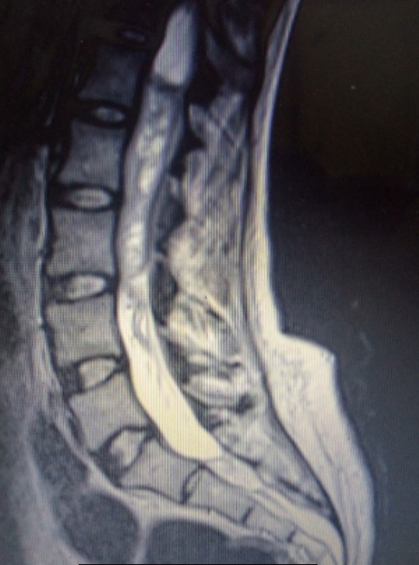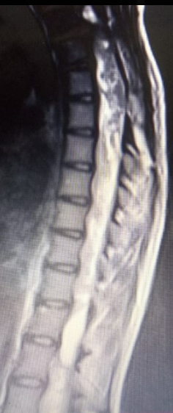
An MRI of a 26 year-old female Nigeria student with a thoracic malignant spinal tumor that rapidly spread to the cervical cord. (? Histology type retrieve case note)

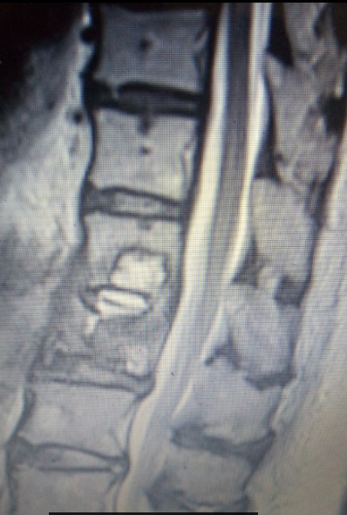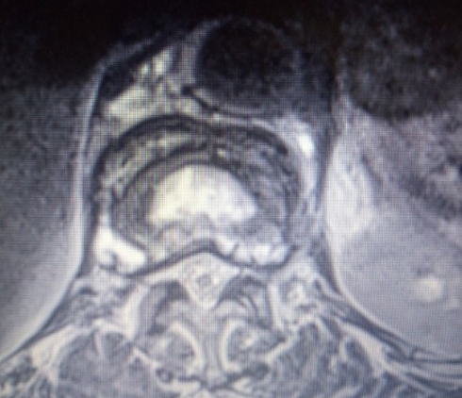
A MRI of a 76 year old elderly Nigerian woman with histology proven multiple myeloma with collapsed L1 vertebra

STAGING AND CLASSIFICATION

The use of classifications that guide the treatment steps is inevitable in patients with malignant spinal tumor. This helps to guide the choice of treatment to offer the patient.
Enneking classification has been used for the classification of benign and malignant tumors of the musculoskeletal system for over 25 years, however n treatment of spine tumors it is insufficient for surgical planning over time.¹⁰

The treatment decision in these patients may be modified through the use of classifications that are capable of evaluating instability (SINS(Spine instability neoplastic score) and Harrington) and prognosis (Tokuhashi et al. and Tomita et al.). These guide therapy and facilitate effective communication between multidisciplinary managing teams.The development of simple classification systems with easy radiographical attributes and patient factors that contribute to and facilitate communication and appropriate referrals between oncologists, radiologists, orthopedic and spine surgeons, and neurosurgeons help to ensure that treatment plans are faster and better optimized.

Establishing criteria for a surgical indication is very difficult due to the variety of symptoms and survival prognoses. Early detection and proper intervention are critical to minimizing the sequelae from spine metastases, reestablishing function, and maximizing the quality of life.
One criticism of the SINS score was that the neurological status of the patient, a potential modifier of the treatment approach, is not included in the evaluation.
Harrington designed a classification scheme with five categories for metastatic tumors of the spine based on bone destruction and neurological impairment. In this score, surgery is indicated only in the presence of vertebral instability or mechanical pain.

In 1990 Tokuhashi et al elaborated a treatment and procedure selection strategy based on life expectancy. In 2005 they revised the tool to improve the precision of this system. The score interval for the parameter “primary site” was changed to 0 to 5 points and the total score possible was increased to a maximum of 15 points. Pre-treatment prognostic evaluation is the most important factor in determining the selection of treatment methods, including surgical procedures. Using this system, life expectancy was consistent with real post-treatment survival time in 86.4% of cases in a prospective series of 118 patients and in 82.5% of cases in a retrospective series of all 246 cases. This fact may be attributed to the presence of a large number of variables and the inclusion of neurological status.
Tomita et al. recommend an alternative prognosis scoring system, taking the histology of the tumor and its biological behavior into account. This system was built based on the retrospective data of 67 patients between 1987 and 1991, and weighted point values were given to prognostic factors following an evaluation of their statistical rates of risk. The histology of the primary tumor is closely correlated with survival in both surgical patients and medical cohorts, with greater survival times observed in patients with breast, prostate, and thyroid cancers. Therefore, the type of primary tumor played a predominant role in the scoring of the Tomita apud Choi et al. system.

Tomita et al have published a classification regarding surgical strategy in spinal metastases in 2001. According to this classification, patient evaluation was
based on 3 prognostic factors: Histopathologic grade of primary tumor, visceral metastasis to vital organs (the lungs, liver, kidneys and brain) and bone metastases including spine metastases (Table 1). Spine metastases were also evaluated in 7 types (Figure 3). As longterm regional control could be provided, the patients whose score is 2-3 points from Tomita classification are suggested to be treated by total en bloc spondylectomy which means marginal or wide resection; as medium term regional control could be provided, the patients
whose score is 4-5 points are suggested to be treated by marginal resection or intralesional treatment (total en bloc spondylectomy or curettage); as they are appropriate for short-term palliation, the patients whose score is 6-7 points are suggested to be treated by palliative surgery like spinal canal decompression and
stabilization; the patients whose score is 8 and above points are suggested to be treated by conservative support treatment instead of surgical treatment

The type and goals of surgery must be determined by the patient’s ability to tolerate the procedure and the anticipated estimated life expectancy. Tokuhashi et al published the preoperative prognostic classification for patients with spine metastases. The classification system was based on general condition of the patient, extraspinal bone metastases, number of metastatic foci in the spine, major visceral metastases, primary cancer focus (origin) and the patient’s neurological status.

The patients with a Tokuhashi score between 12 and 15 points have a life expectancy more than 1 year and this patient group should be treated by tumor excision. The patients with a Tokuhashi score between 9 and 11 points have a life expectancy more than 6 months, and patients in this group with single level spine metastasis but without major internal organ (visceral) metastases should be treated by tumor excision, while the rest should be treated by palliative surgery. The patients with a Tokuhashi score less than 8 points have a life expectancy less than 6 months, and these patients should be treated by palliative surgery or conservative treatment.^{5, 17}
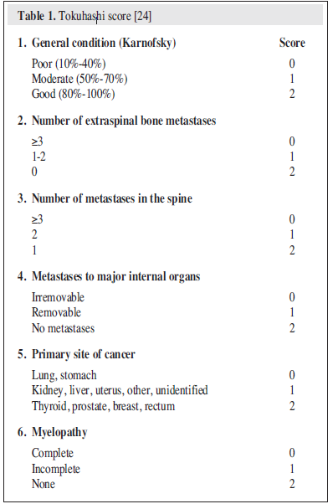

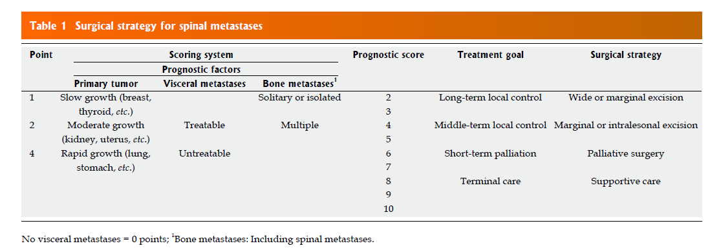
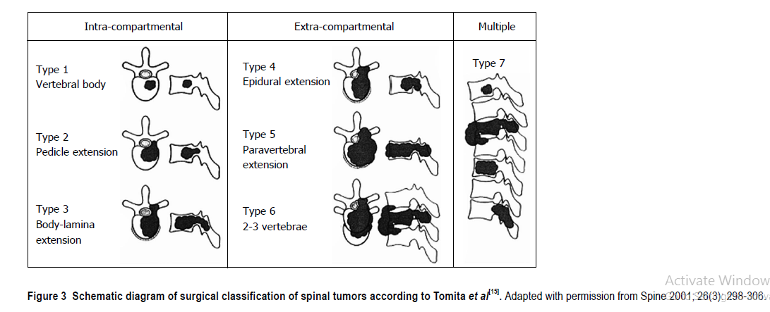

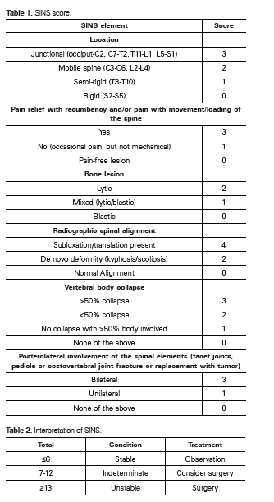
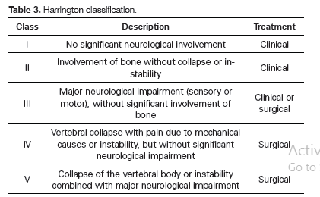

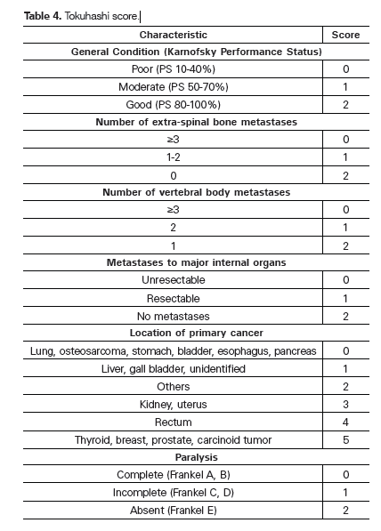

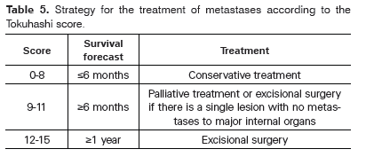

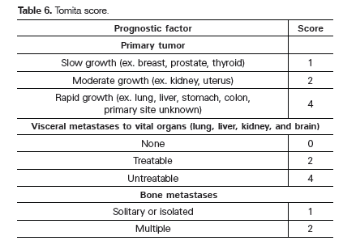

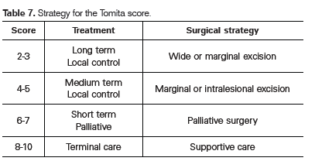
TREATMENT
Surgical Treatment
In spine tumors, main goal of surgical treatment is local control of the local disease.Surgery is the best treatment option for the pain and neurological symptoms caused by spinal instability. Spinal instability, vertebral collapse with or without any neurological deficit, radiotherapy resistant tumors for examples sarcomas, lung, renal cell and colon cancers , intolerable pain unresponsive to conventional therapy and neurological deficit before, during or after the radiotherapy, clinically significant neural compression secondary to retropulsed bone or from spinal deformity are the indications for surgery.^{5,10,16} Neurological recovery is dependent on the rapidity of neurological decline, the duration of the decline and most importantly the neurological status before treatment.¹⁰

General principles of spine tumor surgery are decompression of tumor compression to the spinal cord, establishing a tumor-free solid spine and performing the surgery with minimal morbidity, correct and prevent any further deformity by stabilizing the spine and obtaining a diagnosis if the primary is unknown and preventing local recurrence.^{5,10}

Surgical modalities in metastatic spine tumors are palliative interventions.^{5,10} this include posterior decompression of spinal canal with posterior instrumentation, restoring the bone loss of the vertebral body with cement augmentation techniques (vertebroplasty/kyphoplasty), and total spondylectomy with anterior and posterior stabilization.^{5,9} More recently, minimally invasive techniques such as endoscopy, kyphoplasty/vertebroplasty and steoreotactic radiosurgery are now options of treatment.¹⁰

In primary tumors of the spine, total/partial laminectomy, total/partial vertebral body resection, piece-meal resection and curettage, in addition to the surgical procedures described above, can be used.

Contraindications Paralysis lasting more than 24 hours, expected survival less than 3 months, radiosensitive tumors, involvement of multiple vertebral levels
and sites, poor medical risk factors for surgery. Complications Worsened neurologic deficits, hemorrhage into the cord, infection.

RADIOTHERAPHY
Goal of radiation treatment is to cause necrosis/apoptosis of the tumor, reducing its size and compression of the cord, and to reduce the tumor’s growth rate. Radiation therapy can also ameliorate pain and is usually well tolerated.
Despite the clear benefit of radiotherapy, optimum dosing and treatment regimen are still being evaluated. Treatment is usually given using fractionated intensity-modulated radiation therapy to a total dose of 30 Gy in 3-Gy fractions, one to two spinal segments above and below the affected region.

For nonambulatory patients with epidural metastatic tumors, surgery followed by radiation therapy maximizes neurologic function and modestly lengthens survival. However, palliative radiotherapy alone is recommended for those with neurologic deficits lasting longer than 48 hours, survival prognosis less than 3 months, inability to tolerate surgery, multiple areas of compression, or radiosensitive tumors. An ambulatory patient with a stable spine should be considered for radiation treatment only. The role of chemotherapy for epidural metastatic tumors is not well established. For intramedullary metastases, the role of surgery
and chemo therapy remains controversial and radiation is the mainstay.

Contraindications Active infection, inability to remain still for the treatment.
Complications Increased edema or swelling of the tumor (controlled with corticosteroids), injury to normal tissue, myelosuppression (especially if a
large area is irradiated).

CHEMOTHERAPY
The use of chemotherapy for metastatic spinal cord tumors has never been evaluated in well-designed, randomized trials. The few retrospective studies that exist have failed to show that the addition of chemotherapy provides a statistically significant benefit. It has been theorized that for some chemosensitive tumors (e.g. lymphomas, leukemias , germ cell tumors, and neuroblastomas), chemotherapy may be used first or in conjunction with radiation. Chemotherapy is usually reserved for higher-grade tumors, recurrent tumors, or residual disease.

Chemotherapy for primary spinal tumors is not well established, and information
on the effectiveness of specific chemotherapies is very limited because of the rarity of primary spinal cord tumors, which makes it difficult to design clinical trials.

Dexamethasone, a corticosteroid, is used as a temporizing measure to improve or stabilize neurologic function until definitive treatment. It can be tapered during and after radiotherapy. Dexamethasone should be used in those with neurologic
dysfunction until other treatments take effect, but it can be withheld in the absence of such deficits. The optimal dose of dexamethasone has not been established, however 8mg tds for five days can be given. The goal of corticosteroid treatment is to reduce tumor swelling and inflammation over a very short time. Dexamethasone also should be used for intramedullary disease.
Dosage recommendations vary, as the optimal dosing scheme is not established Main side effects Hypertension, hyperglycemia, mood changes, weight gain, ulcers, insomnia, cataracts, proximal myopathy/weakness, osteoporosis,
opportunistic infections (Candida, Pneumocystis).
EMERGING THERAPY
Stereotactic radiosurgery
Advantages include single-fraction dosing (usually) and more sparing of normal tissue. May provide an alternative for patients not eligible for surgery. Two studies of its use in treating benign intradural spinal tumors have had encouraging results. Standard procedure Includes CyberKnife and gamma-knife technologies. Contraindications Active infection, inability to remain still for the treatment. Complications Risk of radiation necrosis or injury to normal tissue.

SUPPORTIVE CARE
Supportive care is directed at improving patient comfort and preventing
complications associated with malignant spinal cord tumors and their treatments. Pain can arise from bony metastases, spinal instability, surgery, or neuropathic causes (e.g., nerve compression or the effects of radiation or prior chemotherapy). Pain control should be assessed on every visit. Dexamethasone can be helpful for bone-related pain. Non-steroidal anti-inflammatory medications can also be beneficial and should be combined with a proton-pump inhibitor if used chronically. Anticonvulsants such as gabapentin or pregabalin are effective in treating neuropathic pain. Often long-acting opiates are needed, along with shorter-acting opiates for breakthrough pain. Proactive bowel regimens can prevent complications from opiate medications. Bladder dysfunction may require urinary catheterization. Treatments to prevent thromboembolic disease should be considered, including mobilization, compression stockings, and low-dose anticoagulants. The patient’s psychological well-being and social support should be assessed

REHABILITATION
Integration of physical therapy, occupational therapy, and/or speech therapy are key to maximizing patient function after surgery and radiation therapy and optimizing the patient’s quality of life. These therapies can be provided as an inpatient or outpatient. Standard procedure Inpatient rehabilitation stay and/or outpatient access to therapies, usually after evaluation by a rehabilitation physician. Contraindications Patient must be able to participate in therapies safely.

CONCLUSION
Optimal diagnosis and treatment of spine tumors require a multidisciplinary approach and thorough knowledge of both spine surgery and musculoskeletal tumor surgery. Malignant spine tumor is mainly due to metastasis. Delayed diagnosis is not very unusual. Goal of treatment is to optimize the patient’s quality of life by providing effective pain relief and preserving or restoring neurological functions. Treatment strategy should be planned after both oncological and surgical staging. Advances in imaging, surgical techniques and implant technology resulted in better diagnosis and surgical treatment options, especially for early primary tumors. Knowledge about the primary lesion has critical importance in treatment protocol for metastatic tumors of the spine.

REFERENCES
- Carlos A. B, Yevgeniy K., Timothy F. W, Jean-Paul W and Ziya L. G, Surgical Management of Malignant Spinal tumors: Part I. Contemporary Neurosurgery. Vol 29:16 august 15 2007
- Abdu W.A, Provencher M. Primary Bone and Metastatic Tumors of the Cervical Spine. Spine 1998;23: pp 2767-2777.
- Rao S., Davis R.F. Cervical Spine Metastasis. In Editorial Committee, eds. The Cervical Spine. 3rd Edition. 1998:608-18.
- Chon B. et al. Surgery Combined with Radiotherapy to Treat Spinal Tumors: A Review of Published Reports. Orthopedic Surgery 2016; 8:97-104.
- Ciftdemir M, Kaya M, Selcuk E, Yalniz E. Tumors of the spine. World J Orthop 2016; 7(2): 109-116.
- Choi D, Crockard A, Bunger C, Harms J, Kawahara N, Mazel C, Melcher R, Tomita K. Review of metastatic spine tumor classification and indications for surgery: the consensus statement of the Global Spine Tumor Study Group. Eur Spine J 2010; 19:215-222 [PMID: 20039084]
- Aboulaflia AJ, Levine AM. Musculoskeletal and Metastatic Tumors. In: Fardon DF, Garfin SR. OKU: Spine 2, Rosemont. American Academy of Orthopaedic Surgeons, 2002: 411-431
- Deol GS, Haydol R, Phillips FM. Tumors of the Spine. In: Vaccaro AR. OKU 8, Rosemont. American Academy of Orthopaedic Surgeons, 2005: 587-599.
- Tomita K, Kawahara N, Kobayashi T, Yoshida A, Murakami H, Akamaru T. Surgical strategy for spinal metastases. Spine (Phila Pa1976) 2001; 26: 298-306 [PMID: 11224867 DOI: 10.1097/000076 32-200102010-00016]
- Paul K., Meic H. Surgical Management of Spinal Metastasis. The Oncologist 2004; 9:188-196.
- Wong D.A, Fornasier V.L, MacNab I. Spinal Metastasis: the Obvious, the Occult and the Impostors. Spine 1990;15:1-4.
- Byrne T.N. Spinal Cord Compression from Epidural Metastasis. N Eng J. Med. 1992; 327:614-619.
- Schaberg J, Gainor B.J. A Profile of Metastatic Carcinoma of the Spine. Spine 1985; 10:19-20.
- Gerszten P.C, Welch W.C. Current Surgical Management of Metastatic Spine Disease. Oncology (Huntingt) 2000; 14:1013-1024.
- Adams M,Sonntag V.K.H. Surgical Treatment of Metastatic Cervical Spine Disease. Contemporary Neurosurgery. 2001; 23:1-5.
- Davies AM, Cassar-Pullicino VN. Principles of Detection and Diagnosis. In: Davies AM, Sundaram M, James SLJ. Imaging of Bone tumors and Tumor-like Lesions. Berlin: Springer-Verlag, 2009: 111-135 [DOI: 10.1007/978-3-540-77984-1_7]
- Tokuhashi , Matsuzaki H, Oda H, Oshima M, Ryu J. A Revised Scoring System for Preoperative Evaluation of Metastatic Spine Tumor Prognosis. Spine (Phila Pa 1976) 2005; 30: 2186-2191 [PMID: 16205345 DOI: 10.1097/01.brs.0000180401.06919.a5]
- Deol G.S, Haydol R, Phillips F.M. Tumors of the Spine. In: Vaccaro AR. OKU 8, Rosemont. American Academy of Orthopaedic Surgeons, 2005: 587-599
- Boos N , Fuchs B. Primary Tumors of the Spine. In: Boos N, Aebi M. Spinal disorders: Fundamentals of Diagnosis and Treatment. Berlin: Springer-Verlag, 2008: 951-976 [DOI: 10.1007/978-3-540-69091-7].
- Brian V, Monica L. Treatment of Spinal Cord Tumours. In: Current Treatment Options in Neurology 2009, 11:315–324.
- Cole J.S, Patchell R.A: Metastatic epidural spinal cord compression. Lancet Neurol 2008, 7:459–466.
- Davis J.H. Anatomical Classification and Surgical Consideration: Primary Spinal Tumors an Overview.SA Orthop. J Vol.10n.3 Centurion Jan. 2011

