INVESTIGATING PERSONAL HYGIENE PRACTICE AND THE IMPLICATIONS ON EYE HEALTH AMONG ALMAJIRI STUDENTS OF INTEGRATED TSANGAYA MODEL SCHOOLS IN KANO STATE, NIGERIA
HARUNA, B. MURTALA
LINCOLN UNIVERSITY COLLEGE, MALAYSIA
Corresponding Author: HARUNA B. MURTALA
Email: murtalagarki21@gmail.com
G.S.M +2348035908909
Abstract
Background: Personal hygiene is the principle of maintaining the cleanliness and grooming of the exterior part of the body. It entirely depends on the availability of clean and safe water. It includes regular baths with soap and water, regular hand washing especially after using toilet, and before and after eating food, oral hygiene and washing of cloths and linens.
Purpose: The purpose of this study is to investigate the practice of personal hygiene, and its implications on eye health among students of integrated Tsangaya model schools in Kano state, Nigeria.
Methods: Cross-sectional survey was conducted from 13/03/2023 to 03/04/2023 and questionnaire was administered through face to face interview. The study participants recruited were two hundred and seventy three, 234 males (85.7%) and 39 females (14.3%). Systematic random sampling technique was used to sample the study participants. Basic eye examination and visual acuity assessment were also conducted. The hypothesis was tested at 0.05 level of significance. The data collected was sorted and analyzed using STATA Version 13 Software.
Results: The results revealed that, 137(50.1%) of the participants wash their hands sometimes before eating food, while 77 (28.2%) always use soap to take bath. 111 (41%)clean their teeth once daily, while 126 (46%) clean their teeth twice daily.
Conclusion: The study reveals a significant poor personal hygiene practice among the study participants. This can be a predisposing factor to the development of many ocular conditions. Health education to encourage regular baths with soap and water, and hand hygiene should be conducted at regular intervals for students of integrated Tsangaya model schools in Kano state.
Keywords: Almajiri, Tsangaya Model School, Ocular Conditions, Personal Hygiene

INTRODUCTION:
Personal Hygiene is the practice of cleaning the exterior part of the body. The World Health Organization (WHO) defines Hygiene as “concept of cleaning practice aimed at maintaining health and preventing the spread of diseases”. Hygiene is a complex process that involves the combination of various methods and practices in order to achieve cleanliness and sterility (Kumar et al, 2020).
Globally, it is estimated that about 2.3billion people lack basic hygiene services, which includes hand-washing facilities, soap and water in their homes (WASH, 2022). And only 19% of the global population practice hand washing with soap after using the toilet (Kumwenda, 2019). In developing countries poor personal hygiene and water shortage enhance the spread of Ocular infections such as Conjunctivitis and Trachoma (Sight Savers, 2020). It is mandatory to always wash our hands with soap before touching our eyes to prevent the contamination of the eyes with organisms that can cause serious Ocular diseases (Kumwenda, 2019).
THE CONCEPT OF HYGIENE:
The concept of hygiene is well known by the people for over a thousand years ago, it is related to personal care and medicine (Khan, 2015). Hygiene has been classified into two forms: personal hygiene and community hygiene.
Personal Hygiene: personal hygiene is the principle of maintaining the cleanliness and grooming of the exterior part of the body, and it entirely depends on the availability of clean and safe water. It is performed in order to care for the health of the body and well-being. It is achieved through cleanliness, which includes regular baths with soap, regular hand washing with soap especially after using toilet, and before and after eating food, oral hygiene and wearing clean cloths.
Community Hygiene: this is the aspect of environmental sanitation and community activities for the purpose of health protection and promotion. It involves good drainages, availability of toilets to prevent open defecation (OD), and a proper waste disposal system.
Children and Personal Hygiene: according to the Nigerian Demographic and Health Survey (2018) statistics, children aged 0-17 years are 52% of the population in Nigeria. 48% reside in the urban areas, while 52% are residents in the rural areas. It become necessary, children as vulnerable group to train them at an early age the daily routines of personal hygiene, such as oral care, regular baths with soap, hand-washing technique before and after eating food, and also after visit to the toilet (Kumwenda, 2019).
HAND-WASHING:
Hand-washing is also called hand hygiene. It has been recognized as one of the most effective health intervention that can prevent the development of diseases. Hands are used constantly in touching surfaces, eating and in toilet use. Therefore when considering personal hygiene, focus should be directed to the hands. Washing the hands involves the use of soap and water in order to remove harmful micro-organisms and other substances stuck in the hands (Kumwenda, 2019). This will shield the transmission of infectious diseases.
Indications for hand-washing:
Before and after eating food
After toilet use
After touching surfaces/ other people
BATHING:
Bathing is the practice of cleaning the external part of the body with soap and water, in order to keep it clean and hygienic. Ideally to be conducted minimum once daily (Kumar et al, 2020).
ORAL CARE:
It is the practice of cleaning the teeth at least twice daily; morning and evening, in order to prevent the development of gum disease, tooth decay and other infections (Kumar et al, 2020).
HYGIENE SITUATION IN DEVELOPING COUNTRIES:
Majority of the developing countries are struggling with persistent water shortages and deficient water infrastructure (Kumar et al, 2020), creating lack of good personal hygiene in this countries. This predisposes children and the vulnerable population to the risk of developing water, sanitation and hygiene related diseases such as Trachoma (Das et al, 2020).Only 1 in 3 people in the rural areas, have access to soap and water, which are the basic hygiene services (WASH, 2022).

TRACHOMA:
Trachoma is an infection of the eye caused by Chlamydia Trachomatis. It is spread by way of person to person contact, or through the eye seeking flies (Weinstock & Bainter, 2023). Repeated infection with Chlamydia trachomatis leads to the development of chronic kerato-conjunctivtiss, (Lee, 2023). It is the leading cause of infectious blindness globally. The prevalence rate of infection is between 60-90% among school-age children (WHO, 2022). Trachoma is common in hot and dusty environment that lack basic sanitation, mostly in remote and rural areas of developing countries. It is estimated that there are about 40 million people with active trachoma globally and about 1.2 billion living in endemic areas (Sight Savers, 2010), with about 48% prevalence rate in Sub-Saharan Africa and India (AAO, 2013). About 1.9million people are blind globally as a result of trachoma infection (Weinstock & Bainter, 2023). Poor hygiene practices and weak eye care services contributed significantly to the development of trachoma in developing countries (Sight Savers, 2010).
TSANGAYA SCHOOL SYSTEM:
Tsangaya refers to a place where teaching and learning the holy Qur’an takes place. It was derived from the Kanuri word Sangaya, which means educational institution, but it was altered in Hausa language to Tsangaya, (Bano et al, 2011). The system has a long history traceable to the scholastic culture of Timbuktu in Mali republic, West African sub-region. The system becomes established since the pre-colonial era, with the aim of educating the almajiri student on reading, writing, and memorization of the Holy Qur’an (Idriss & Hamzah, 2021). In the bid to acquire this knowledge, the almajiri face multifarious welfare problems. They have no decent accommodation for studies or sleeping, they have to beg in order to eat, no soap to clean their bodies and clothes, and no any provision for health care services (Galadanchi, 2014).
In an effort to modify the Tsangaya system, Kano state government integrate some of these Tsangaya schools in the state, to run both the traditional Tsangaya system and western type of education concurrently, and referred them as integrated Tsangaya model schools (ESSPIN, 2017).

PURPOSE OF THE STUDY:
The purpose of this study is to investigate the practice of personal hygiene and its implications on eye health, among students of integrated Tsangaya model schools in Kano state.

MATERIALS AND METHODS:
This is a cross-sectional descriptive survey, conducted among students of integrated Tsangaya model schools (ITMS), in Kano state. Kano state is one of the 36 states of the Federal Republic of Nigeria. It is located in the north-western part of the country, with a population of 12,401,288 people (UN Survey, 2021). The study population is two thousand nine hundred and seven (2907), almajiri students.
Inclusion criteria: all the almajiri students of ITMS resident at the school for a period of not less than one year and consented to participate are included in the study.
Exclusion criteria: all non-resident almajiri students of ITMS and less than one year duration at the school, and those that do not consented for the study were excluded from the study.
Approval to conduct the study was provided by Kano state Tsangaya and Islamiyya Schools Management Board, in line with the Helsinki declaration. Oral consent was also collected from the participants and their guardians.
The sample size of the participants was two hundred and seventy three almajiris students, determined using the Kreijce & Morgan (2012) table for sample determination. The research assistants were trained on the data collection procedure and the visual acuity assessment method.
Pilot study: Prior to the conduct of the main study, a pilot study was conducted on fifteen (15) almajiris pupils of non-integrated Tsangaya School.
Instrument of study: the instrument of study is a well structured validated questionnaire. The validation of the instrument was done by an ophthalmologist, psychologist, Islamic scholar, Child-health nurse and an educationist. All issues raised were implemented before administering the instrument.
The researcher together with the research assistants administered the questionnaire through a well-structured interview method at the school premises. Data collection goes hand in hand with interview. Distance Visual acuity was assessed with the aid of Snellen’s chart. The external part of the eye was examined using pen torch and the internal part of the eye was examined with the aid of a direct ophthalmoscope. The results of the eye examinations were recorded into the participants form provided.
The data collected were sorted and analyzed using STATA Version 13.
PICTURE 1: SHOWING THE SOURCE OF WATER FOR THE FEMALE STUDENTS 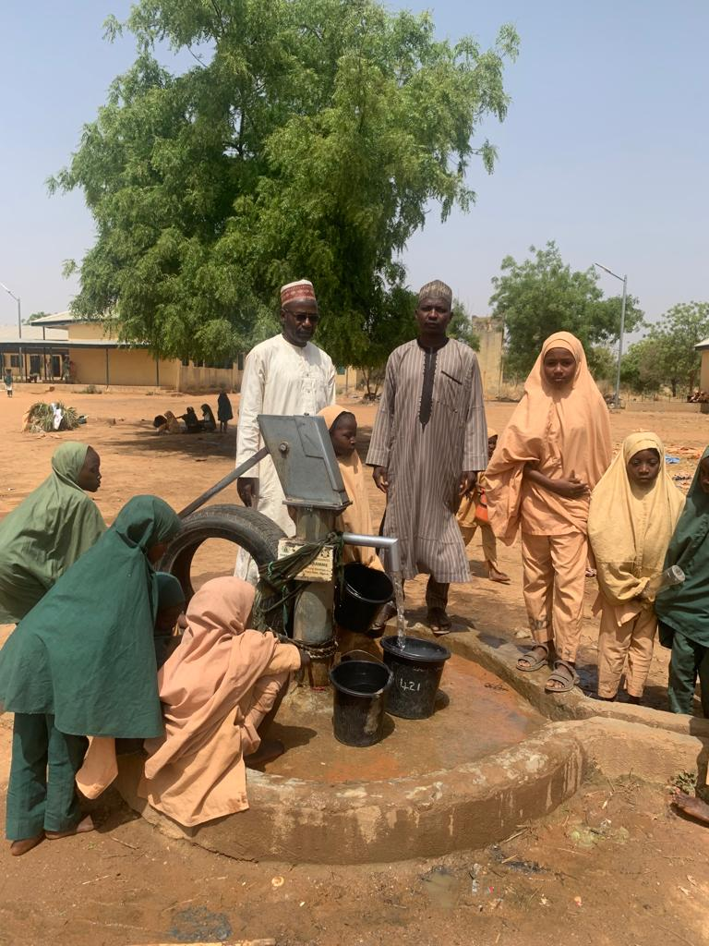
PICTURE 2 SHOWING MALE TSANGAYA STUDENT SOURCE OF WATER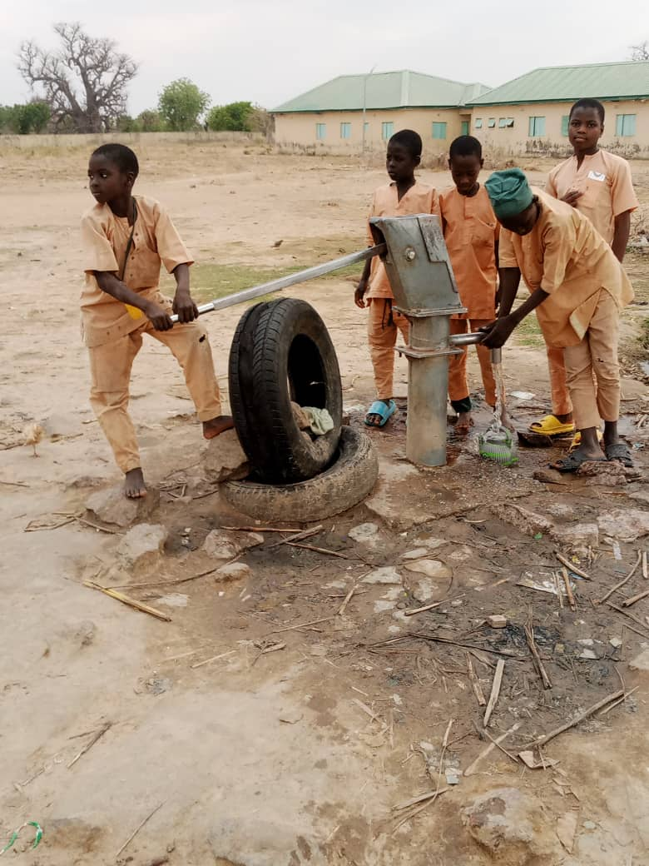
RESULTS:

TABLE 1: SHOWING PARTICIPANTS FREQUENCY OF HAND WASHNG BEFORE EATING
FREQUENCY OF HAND WASHING BEFORE EATING | PARTICIPANTS NUMBER | PERCENTAGE
RARELY | 4 | 1.5
SOMETIMES | 137 | 50.1
MOST OF THE TIMES | 97 | 35.5
ALWAYS | 35 | 12.8
TOTAL | 273 | 100
SOURCE: RESEARCHER’S FIELD WORK 2023

TABLE 2: SHOWING PARTICIPANTS PRACTICE OF HAND WASHING WITH SOAP AFTER TOILET USE
FREQUENCY OF HAND WASHING WITH SOAP | PARTICIPANTS NUMBER | PERCENTAGE
RARELY | 3 | 11
SOMETIMES | 112 | 41
MOST OF THE TIMES | 122 | 44.7
ALWAYS | 36 | 13.2
TOTAL | 273 | 100
SOURCE: RESEARCHER’S FIELD WORK 2023

TABLE 3: SHOWING FREQUENCY OF TEETH CLEANING BY PARTICIPANTS
FREQUENCY OF TEETH CLEANING | PARTICIPANTS NUMBER | PERCENTAGE OF PARTICIPANTS
CLEAN TEETH ONCE DAILY | 111 | 41
CLEAN TEETH TWICE DAILY | 126 | 46
CLEAN TEETH MORE THAN TWICE DAILY | 36 | 13
TOTAL | 273 | 100
SOURCE: RESEARCHER’S FIELD WORK 2023

TABLE 4: SHOWING RESULT OF EYE EXAMINATION OF PARTICIPANTS
RESULT OF EYE EXAMINATION | PARTICIPANTS NUMBER | PERCENTAGE OF PARTICIPANTS
NORMAL FINDINGS | 115 | 42.1
PRESENCE OF OCULAR CONDITION | 158 | 57.9
TOTAL | 273 | 100
SOURCE: RESEARCHER’S FIELD WORK 2023

TABLE 5: SHOWING PARTICIPANTS TYPES OF OCULAR CONDITIONS
TYPE OF OCULAR CONDITION | PARTICIPANTS NUMBER | PERCENTAGE OF PARTICIPANTS
CONJUNCTIVITIS | 127 | 80.4
REFRACTIVE ERROR | 28 | 17.7
CORNEAL FOREIGN BODY | 1 | 0.6
CORNEAL SCAR | 1 | 0.6
GLAUCOMA SUSPECT | 1 | 0.6
TOTAL | 273 | 100
SOURCE: RESEARCHER’S FIELD WORK 2023

Table 1 shows that 12.8% (n=35) of the participants always wash their hands before eating, 35.5% (n=97) wash their hands most of the time before eating, 50.1% (n=137) of the participants sometimes wash their hand before eating, while 1.5% (n=4) of the participants rarely wash their hands before eating. The result shows that the first group 12.8% and the second group 35.5%, totaling 48.3%, maintained the standard of regularly washing their hands before eating.
Table 2 shows that 13.2% (n=36) of the participants always wash their hands with soap after toilet use, 44.7% (n=122) of the participants wash their hands most of the times after toilet use with soap, 41% (n= 112) of the participants sometimes wash their hands with soap after toilet use, and 1.1% (n=3) of the participants rarely wash their hands with soap after toilet use. This result revealed a significant practice of hand washing with soap after toilet use among the participants, considering the number 44.7% that wash their hands most of the times and 13.2% that always wash their hands with soap after toilet use, totaling 57.9%.
Table 3 revealed the practice of dental hygiene among the participants, which is part of personal hygiene practice. From the table 13% (n=36) of the participants clean their teeth more than twice daily, 46% (n=126) of the participants clean their teeth twice daily and 41% (n=111) clean their teeth once daily. This shows a significant practice of dental hygiene among the participants, considering the 46% of the participants that clean their teeth twice daily and the 13% of the participants that clean their teeth more than twice daily, totaling 59%.
Table 4 shows that majority of the participants (57.9%) have various types of eye problems, despite the high level of personal hygiene.
Table 5 shows the various types of eye conditions among the participants, such as conjunctivitis (80.4%), refractive error (17.7%), corneal foreign body (0.6%), corneal scar (0.6%) and Glaucoma suspect (0.6%). This shows conjunctivitis is the most common eye condition among the participants, followed by refractive error.
DISCUSSIONS OF FINDINGS:
The aim of this study is to investigate personal hygiene practice and its implications for eye health among students of ITMS in Kano state. Personal hygiene practice involves the regular daily baths, washing the hands before eating, washing the hands with soap after defecation, daily cleaning the teeth and washing the hands with soap after handling any dirty objects or surfaces (Health direct, 2021). This study however, revealed a significant high level, of personal hygiene practice among the participants, but the results also revealed a significant high level (57.9%) prevalence of eye conditions among the participants, which can be attributed to other confounding variables, such as nutrition and environment. Table 5 shows the various types of eye diseases prevalent among the participants, with conjunctivitis 80.4%, refractive error 17.7%, corneal foreign body 0.6%, corneal scar 0.6% and glaucoma suspect 0.6%. A study conducted by Ekpenyong et al (2017) on the visual status of school age children in southern, Nigeria shows 32.1% prevalence of eye diseases among the participants, with conjunctivitis 18.8% and refractive error 11.5%. The two studies are similar in their results, showing conjunctivitis as the most common eye condition among school age children. This can be attributed to the similarity of the geo-political settings of the two studies. A similar study conducted by Agrawal et al (2020) on the prevalence of ocular morbidities among school children in Raipur district, India, shows 21.2% prevalence of eye conditions among the participants, with vitamin A deficiency most common (10%) and refractive error (5.2%). The differences with this study can be attributed in the geo-political and socio-cultural variation of the settings of the two studies. There is paucity of studies conducted on personal hygiene practices of school-children. Most studies focus on the importance and implications of personal hygiene practices. However, in a study conducted by Azuamah et al (2018), among patients attending Optometry clinic at Federal University Teaching Hospital in Owerri, Nigeria, shows 13.36% of the patients wash their hands before eating and 19.35% wash their hands with soap and water after defecation. This number is significantly low compared with this study that revealed 35.5% and 12.8% (48.6%) of the participants that regularly wash their hands before eating, and 44.7% and 13.2% (57.9%) that regularly wash their hands with soap and water after defecation. The differences between the two studies can be attributed to socio-cultural differences between the two study settings. Hands become soiled when it become in contact with human feces or soil (from worm eggs), that requires effective hand-washing with soap and sufficient water to rinse it off (Bolt, 2005). Humans spread infection by the micro-organisms present in different parts of their body; hair, nose, mouth, hands, finger nails and clothes. According to Sinert (2021), good personal hygiene can prevent the development of hygiene related diseases. The spread of conjunctivitis can be prevented through regular hand washing with soap and warm water during epidemics of infectious conjunctivitis or Pink eye, (CDC, 2017). Poor personal hygiene can lead to contamination with micro-organisms that cause ocular infections when contact with the eye (Dozie, et al 2018). Trachoma the leading cause of infectious preventable blindness spread as a result of poor personal hygiene (WASH, 2021). Without socio-medical intervention, repeated infections with Chlamydia trachomatis lead to conjunctival scarring, trichiasis, and corneal opacity, that ultimately result to irreversible blindness (CDC, 2020).
CONCLUSION:
The study revealed a significant high level of personal hygiene practice among almajiri students of ITMS in Kano state, with a high prevalence of ocular conditions, which could be associated with other confounding variables, such as nutrition and environmental factors. The high level of personal hygiene practice can be attributed to the importance of cleanliness and purity place by the religion of Islam, especially before performing any religious duty.

RECOMMENDATION:
The following recommendations are considered crucial in order to maintain the high level of personal hygiene practice at ITMS and other Schools.
Incorporating Personal Hygiene Health education into the curriculum of ITMS and other schools.
Provision of clean and safe water for the students at ITMS and other schools.
Provision of soap to students of ITMS, by authorities, parents and other donor agencies in order to facilitate efficient personal hygiene practice by the students.
Regular supervision and monitoring of personal hygiene practice at ITMS and other schools, by the school authorities and parents/guardians.
Personal hygiene health education lectures should be conducted regularly to the students, teachers as well as parents/guardians.

CONFLICT OF INTEREST: NIL

REFERENCES
Agrawal, Deepansh. Sahu, Anupam. Agrawal, Deepshikha. (2020), Prevalence of Ocular Morbidities among school children in Raipur district, India, Indian Journal of Ophthalmology, DOI: 10.4103/ijo_1454_19, www.ijo.in
Azuamah, YC. Esenwah, EC. Ahuama, OC. Ikoro, NC. Iwuagwu, FC. Dozie INS, (2018), External eye infections and personal hygiene practices among patients attending Optometry clinic, Federal University of Technology Owerri, Nigeria. Journal of the Nigerian Optometric Association, 20 (2): 53-61
Bolt, Eveline (2020), Personal Hygiene behavior, https://www.iboro.ac.uk
Eyes-Trachoma. Better Health channel, (2020), https://www.betterhealth.vic.gov.au/health/conditions and treatments/eyes
Ekpenyong, Bernadine. Ahaiwe, Kelechukwu. Shunmugam, Kovin, Naidoo. Ekanem, Ekanem. (2017), Visual status and prevalence of eye disorders among school-age children in Southern, Nigeria, African Vision and Eye Health https://www.researchgate.net/publication/317960199
ESSPIN © 2017
Frank, J, Weinstock. P., S, B. (2023), https://www.medicinenet.com
Galadanci, B. S. (2014), Reforms for the promotion and development of Tsangaya schools in the context of the Nigerian Educational system. Bayero University Kano. https://www.buk.edu.ng
Global water, sanitation and hygiene (2022), https://www.cdc,gov/wash-statistics
Idriss, D., Ibrahim. H., & Norhayati, H. (2021), Tsangaya system of education and its positive effects on Almajiri and society in Potiskum, Yobe state, Nigeria. Journal of Al-Tamaddun (16), (2): 89-97, https://doi.org/10.22452/JAT.vo116: 2.7
Kumar, S., Meghana, B., Reddy, P., Paul, A., Prolay, D, Lipika, D. J., Kurian, C., B. P., Gosh,B. P., & Sayantan, R.B.N. (2020), Importance of Understanding the need of Personal Hygiene: A comprehensive review. International Journal of Research in Pharmacy and Pharmaceutical sciences, www.pharmacyjournal.in (5), (6): 56-61
Kumwenda, S. (2019), Challenges to Hygiene improvement in developing countries. DOI:10.5772/intechOpen.80355
Lee, A. G. (2023), https://emedicine.medscape.com
Naeem, Z., Baig. A., & Safdar, S. M. (2021). Relevance and importance of personal hygiene in the maintenance of human health. Journal of Integrated Community Health. https://www.researchgate.net/publication/349588487
National school eye health guidelines. Federal Ministry of Health, Nigeria (2020), https:www.health.gov.ng
Oxford English Dictionary (2018), https://www.oed.com
Personal hygiene (2021), Health direct, https://www.healthdirect.gov.au/personal-hygiene
Sinert, R. H. (2021), Hygiene-related diseases, https://reference.medscape.com/950051
Valley eye care center © 2019, https://valleyeyecareaz.com
Water, Sanitation and Environmentally related Hygiene (WASH). Center for Disease Control and Prevention, CDC (2022)
World Health Organization, WHO (2021), https://www.afro.who.int

