- Introduction
  - Background Information
Microbes are ever-present with many associated with undesirable consequences, such as product spoilage and disease, hence it is important to either kill a wide variety of microorganisms or inhibit their growth to minimise their destructive effect (Choramo, 2022). Various chemical and physical methods can help control microbes with a twofold goal: a) to destroy pathogens and prevent their transmission and b) to reduce or eliminate microorganisms responsible for the contamination of water, food, and other substances (Parija, 2012).
In this study, various chemicals considered to have microbicidal properties were selected along with a wide range of temperatures per varying time intervals to destroy pathogens and prevent their transmission, thus reducing microbial contamination on product and plants.
According to Parija, (2012), an ideal chemical disinfectant or antiseptic should have a wide spectrum of antimicrobial activity – it must be effective against Gram-positive and Gram-negative bacteria, acid-fast bacteria, bacterial endospores, fungi, and viruses at high dilutions; it should act in the presence of organic matter; it should not be toxic or corrosive to humans; it should be stable upon storage and should not undergo any chemical change, and it should have a speedy action.
On the other hand, high temperatures are known to be microbicidal, whereas lower temperatures are known to have inhibitory or micro-bistatic effects. Of the two types of physical heat used in sterilisation – moist and dry heat, this study focused solely on dry heat using an oven. This is the most widely used method. The hot-air oven is electrically heated and is fitted with a fan to ensure adequate and even distribution of hot air in the chamber. It is also fitted with a thermostat that ensures hot air circulation at the desired temperature in the chamber. Parija further notes that sterilisation by hot-air oven requires exposure to 160-180 °C for 2 hours and 30 minutes, to ensure thorough heating and destruction of spores. However, this poses a risk to overall plant health.

  - Problem Statement
The prevailing bioburden faced by Cannabis plants cultivated at MG Health (MGH) warrants rapid and aggressive interventions to alleviate the burden and boost production through the decrease in the quantity of rejected products.
  - Aim
The rationale of this study is to determine the efficacy of various chemical and thermal treatments in sterilizing Cannabis plants cultivated in a controlled environment at MGH hence rendering them free of a wide variety of pathogenic microorganisms.
  - Objectives
    - To prepare different chemical disinfectants at concentrations supported by literature to be effective against pathogenic microorganisms.
    - To strike a balance between high temperatures to kill pathogenic microorganisms and the survival of a plant exposed to those high temperatures.
    - To pre-sample Cannabis leaves and flowers (flos.) and determine the existing bioburden on the plants before treatment.
    - To expose infected plants to these treatments and assess their effectiveness and efficiency in killing pathogenic microorganisms.
    - To compare the Cannabinoid (CN) and Terpene profile of Cannabis flos. before and after treatment.
    - To compare the organoleptic properties of treated flos. and untreated flos.
    - To monitor the condition of treated mother plants with time.

- Abbreviations
Table 1: Abbreviations
Abbreviation | Explanation
% | Per cent
°C | Degrees Celsius
CN | Cannabinoid
EDTA | Ethylenediaminetetraacetic acid
Entero. | Enterobacteriaceae
Flos. | Flowers
H. italicum | Helichrysum italicum
H₂O₂ | Hydrogen Peroxide
ID | Identification
m/v | Mass per volume
PAA | Peracetic acid
Pseudo | Pseudomonas aeruginosa
R&D | Research and Development
SN | Sequential numbering
TP | Terpene Profile
v/v | Volume per volume

- Definitions
Table 2: Definitions
Concept/Word | Definition
Bioburden | The total number of viable microorganisms associated with a specific product before sterilisation
Dry heat vs Moist Heat | Dry heat makes use of air with a low moisture content that has been heated by a flame or electric heating coil, while.  Moist heat occurs in the form of hot water, boiling water, or steam (vaporised water).
Microbicidal | An agent that kills microorganisms.
Sporicidal | An agent that kills microbial spores.
Sterilisation | A process by which an article, surface, or medium is freed of all living microorganisms either in the vegetative or in the spore state.

- Materials and Equipment
  - 70 % ethanol
  - Daklapacks
  - Ethylenediaminetetraacetic acid (EDTA)
  - Flowering Cannabis plants
  - Helichrysum italicum hydrosol
  - Hydrogen peroxide (H₂O₂)
  - Oven
  - Oxisan (Peracetic acid (PAA))
  - Pruning sheers
  - Vegging Cannabis plants
  - Weighing balance

- Experimental Procedure/Plan
  - Chemical Treatment
    - Sampling and Sampling Plan
      - Treatment 1
Table 3: Chemical treatment sample distribution
SN | Chemical | Replicate | Sample ID
1 | PAA | 1 | B1F2G3
1 | PAA | 2 | B1F2G3
1 | PAA | 3 | B1F2G3
2 | PAA+EDTA | 1 | B1M1G2
2 | PAA+EDTA | 2 | B1M1G2
2 | PAA+EDTA | 3 | B1M1G2
3 | H₂O₂+EDTA | 1 | B2F2G1
3 | H₂O₂+EDTA | 2 | B2F2G1
3 | H₂O₂+EDTA | 3 | B2F2G1
4 | H. italicum Hydrosol + EDTA | 1 | B1F2G2
4 | H. italicum Hydrosol + EDTA | 2 | B1F2G2
4 | H. italicum Hydrosol + EDTA | 3 | B1F2G2
5 | H. italicum Hydrosol | 1 | B2F2G3
5 | H. italicum Hydrosol | 2 | B2F2G3
5 | H. italicum Hydrosol | 3 | B2F2G3

Cannabis plants (56 flowering plants) in Pad 1, Multispan A were identified and selected according to their microbial hotspots. Flower Samples (Pre-treatment samples) were taken and tested for the initial microbial load a week before treatment. After sampling, selected plants were isolated into a controlled R&D container before both chemical and thermal treatments were executed. These selected Cannabis plants were rationed such that fifteen (15) were for chemical treatment, thirty (30) for heat treatment and nine (9) were controls. For chemical treatment, chemicals listed in Table 3 were sprayed on every part of the triplicate plants (see Table 3) two days before post-treatment sampling. Post-treatment sampling was done on the day samples were taken to the laboratory for microbial analysis.

      - Treatment 2
Table 4: Chemical Treatment of the untreated plants (Treatment 1 controls)
SN | Chemical | Replicate No. | Sample ID
M5806 Flowering Plant
1 | PAA | 001 | B1b2b3G1
2 | PAA+EDTA | 002 | B1b2b3G1
Cannabis Mothers FTB220903P.0003
3 | PAA | N/A | FTB230104PE.0001
4 | PAA+EDTA | N/A | 612F221210P.0003

Similarly, Pretreatment samples of Cannabis flos. were taken a week before treatment 2 was done. The chemicals that were used are listed in Table 4 above, on the control plants from treatment 1.

      - Treatment 3
Table 5: Different Concentrations of Active Chemicals for Treatment of Vegging Plants (Young Mother Plants)
SN | Chemical | Sample ID
1 | PAA (0.3% v/v) | G01
2 | PAA (0.3% v/v) | G02
3 | PAA (0.3% v/v) + EDTA (1.46 v/v%) | G03
4 | PAA (0.3% v/v) + EDTA (1.46 % m/v) | G04
5 | PAA (0.15% v/v) | G05
6 | PAA (0.15% v/v) | G06
7 | PAA (0.3%) + EDTA (0.35 % v/v) | G07

Different concentrations of PAA and EDTA in various combinations as demonstrated in Table 5 were sprayed on a group of Vegging plants (a group was made of 5 plants). The Pre-treatment sampling of plant leaves, spraying of plants, and post-treatment sampling were done on one day and samples were sent to the laboratory for microbial analysis.
    - Preparation of chemical concentrations
      - Treatment 1
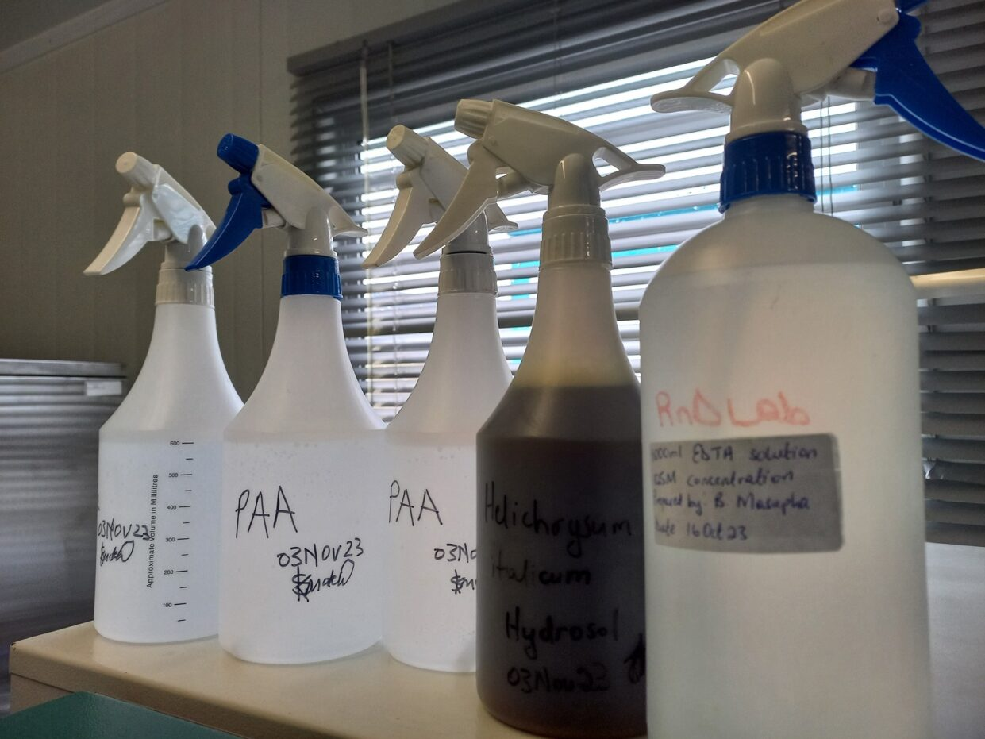
Figure 1: Chemical preparations used to spray cannabis plants: PAA, EDTA, H. italicum hydrosol, and H₂O₂.
Table 6: Concentrations of chemicals used to spray Cannabis plants.
Chemical/Preparation | Concentration
H₂O₂ | 0.5 % (v/v)
PAA | 0.3 % (v/v)
EDTA | 1.46 % (m/v)
H. italicum Hydrosol | N/A

After an intensive literature review of the chemicals used in this study, the concentrations listed in Table 6 were considered to be effective on various microorganisms. However, since Helichrysum italicum hydrosol is an organic substance, its concentration was said to be directly proportional to its potential effectiveness. These preparations were made by diluting stock concentrations with Reverse Osmosis (RO) water to achieve the desired concentrations.

      - Treatment 2
For this treatment, PAA was prepared at a concentration of 0.3 % (v/v) while EDTA was at 1.46 % (m/v).

      - Treatment 3
Varying concentrations were prepared with 0.15 % and 0.3 % for PAA, and 1.46 % and 0.35 % for EDTA (see Table 5).

    - Spraying of chemicals

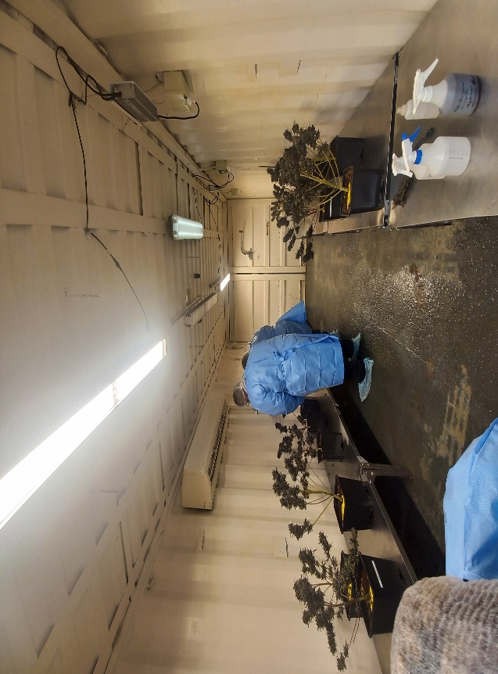
Figure 2: Chemical Spraying of Cannabis plants in the R&D container
As depicted in Figure 2 above, Cannabis plants were spatially arranged in a controlled R&D container and sprayed with various chemicals. The spraying was done in such a way that every part of the plant was in contact with the chemical from the aerial parts (Cannabis flos. and Leaves) down to the stalk of the plant. Where a combination of chemicals was sprayed, EDTA was first sprayed (since it is a chelating agent) followed by an assigned chemical. The chemicals were left to act on the microorganisms for 1- 48 hours before sampling was done for microbial analysis. The chemicals per sample were allocated according to Tables 3, 4 and 5 for Treatments 1, 2 and 3 respectively.

  - Thermal Treatment (Hot dry air)
    - Treatment 1

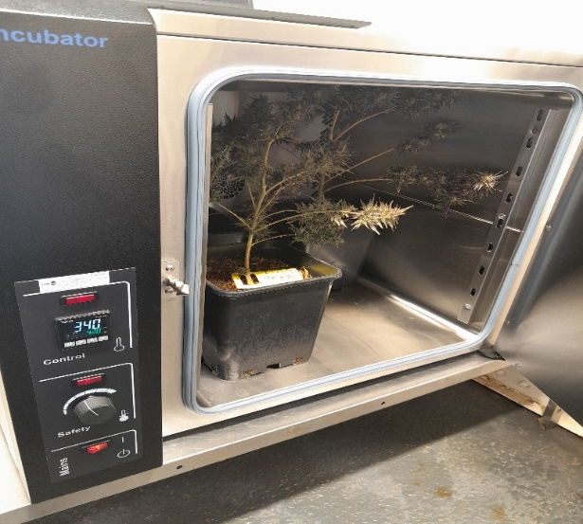
Figure 3: Thermal treatment of Cannabis plants in an Oven.
The oven chamber was allowed to reach the set desired temperatures before the plants were placed into the chamber in triplicates. Once the plants were inside the oven chamber, temperatures were allowed to reach the set points before different time intervals were recorded. Post-treatment samples were taken after 24 hours for microbial analysis.

Table 7: Different temperatures at various time intervals for heat treatment of Cannabis plants
SN | Temperature  (°C) | Time (minutes) | Replicate | Sample ID | Time in | Time out
1 | 42 | 5 | 1 | B1F2G1 | 8:04 | 8:09
1 | 42 | 5 | 2 | B1F2G1 | 8:04 | 8:09
1 | 42 | 5 | 3 | B1F2G1 | 8:04 | 8:09
1 | 42 | 10 | 1 | B2M3G2 | 8:26 | 8:36
1 | 42 | 10 | 2 | B2M3G2 | 8:26 | 8:36
1 | 42 | 10 | 3 | B2M3G2 | 8:26 | 8:36
2 | 45 | 5 | 1 | B1M1G3 | 8:52 | 8:57
2 | 45 | 5 | 2 | B1M1G3 | 8:52 | 8:57
2 | 45 | 5 | 3 | B1M1G3 | 8:52 | 8:57
2 | 45 | 10 | 1 | B2M3G1 | 9:08 | 9:18
2 | 45 | 10 | 2 | B2M3G1 | 9:08 | 9:18
2 | 45 | 10 | 3 | B2M3G1 | 9:08 | 9:18
3 | 50 | 5 | 1 | B1M1G1 | 9:35 | 9:40
3 | 50 | 5 | 2 | B1M1G1 | 9:35 | 9:40
3 | 50 | 5 | 3 | B1M1G1 | 9:35 | 9:40
3 | 50 | 10 | 1 | B2M3G3 | 9:54 | 10:04
3 | 50 | 10 | 2 | B2M3G3 | 9:54 | 10:04
3 | 50 | 10 | 3 | B2M3G3 | 9:54 | 10:04
4 | 53 | 2 | 1 | B2F2G2 | 10:20 | 10:22
4 | 53 | 2 | 2 | B2F2G2 | 10:20 | 10:22
4 | 53 | 2 | 3 | B2F2G2 | 10:20 | 10:22
4 | 53 | 10 | 1 | B2BIG3 | 10:38 | 10:48
4 | 53 | 10 | 2 | B2BIG3 | 10:38 | 10:48
4 | 53 | 10 | 3 | B2BIG3 | 10:38 | 10:48
5 | 55 | 1 | 1 | B2B1G2 | 11:04 | 11:05
5 | 55 | 1 | 2 | B2B1G2 | 11:04 | 11:05
5 | 55 | 1 | 3 | B2B1G2 | 11:04 | 11:05
5 | 55 | 5 | 1 | B2B1G2 | 11:17 | 11:22
5 | 55 | 5 | 2 | B2B1G2 | 11:17 | 11:22
5 | 55 | 5 | 3 | B2B1G2 | 11:17 | 11:22

    - Treatment 2
Table 8: Heat Treatment of Treatment 1 Controls
SN | Temperature (°C) | Time (minutes) | Replicate | Sample ID | Time in | Time out
1 | 55 | 10 | 003 | B1b2b3G1 | 8:59 | 9:09
2 | 55 | 15 | 001 | B1b2b3G2 | 8:59 | 9:14
3 | 60 | 10 | 002 | B1b2b3G2 | 9:21 | 9:31
4 | 50 | 30 | 003 | B1b2b3G2 | 8:09 | 8:39

Flowering plants that were not treated in the first treatment were treated at longer time intervals compared to the first treatment, see Tables 7 and 8.

  - Other Treatments
Table 9: Pilot scale Treatments done on production plants.
Treatment Type | Details | Tests Done
- Oxisan fumigation | Pad 3, Room 5 | CN analysis  TP analysis
- Oxisan fumigation  (V-DL23002) | Selected plants treated in the R&D container | Sensory  Microbial analysis

A group of Cannabis flos. from Pad 3 Room 5 was sampled before and after the room was fumigated with Peracetic acid (PAA) in the form of Oxisan. These samples were oven-dried at 20 °C in the R&D laboratory for 3 days and then analysed for CN concentration and Terpene profile (TP). Similarly, a group of five (5) flowering plants was isolated into the R&D container and fogged with PAA a day before the harvest day. These plants were harvested in parallel with commercial plants of the same batch, processed, and organoleptic properties compared with untreated Cannabis flos.

- Results and Discussions
  - Chemical Treatment
    - Treatment 1
Table 10: Microbiology results for the first chemical treatment of Cannabis Flos.
Chemical/Combination | Microorganisms | Before treatment | After treatment | COA/Test Report Reference
PAA + EDTA | TAMC | < 10 | < 10 | 1474/23 and 1508/23
PAA + EDTA | Enterobacteriaceae | Absent | Absent | 1474/23 and 1508/23
PAA + EDTA | P. aeruginosa | Absent | Absent | 1474/23 and 1508/23
PAA + EDTA | TYMC | 70 | < 10 | 1474/23 and 1508/23
H. italicum Hydrosol + EDTA | TAMC | 100 | 940 | 1480/23 and 1514/23
H. italicum Hydrosol + EDTA | Enterobacteriaceae | Absent | Absent | 1480/23 and 1514/23
H. italicum Hydrosol + EDTA | P. aeruginosa | Absent | Absent | 1480/23 and 1514/23
H. italicum Hydrosol + EDTA | TYMC | 90 | 9400 | 1480/23 and 1514/23
PAA | TAMC | 50 | < 10 | 1481/23 and 1515/23
PAA | Enterobacteriaceae | Absent | Absent | 1481/23 and 1515/23
PAA | P. aeruginosa | Absent | Absent | 1481/23 and 1515/23
PAA | TYMC | 210 | 180 | 1481/23 and 1515/23
Hydrogen Peroxide + EDTA | TAMC | 2400 | < 10 | 1482/23 and 1516/23
Hydrogen Peroxide + EDTA | Enterobacteriaceae | 940 | Absent | 1482/23 and 1516/23
Hydrogen Peroxide + EDTA | P. aeruginosa | Absent | Absent | 1482/23 and 1516/23
Hydrogen Peroxide + EDTA | TYMC | 200 | 190 | 1482/23 and 1516/23
H. italicum Hydrosol | TAMC | 50 | < 10 | 1484/23 and 1518/23
H. italicum Hydrosol | Enterobacteriaceae | Absent | Absent | 1484/23 and 1518/23
H. italicum Hydrosol | P. aeruginosa | Absent | Absent | 1484/23 and 1518/23
H. italicum Hydrosol | TYMC | 60 | < 10 | 1484/23 and 1518/23

From this treatment, a number of chemical combinations were observed to show some antimicrobial activity towards the microorganisms of interest in this study, except the combination of H. italicum Hydrosol and EDTA, which saw a rise in post-treatment microorganisms (see Table 10). This was seen as an anomaly since the expectation was for the combination of H. italicum Hydrosol and EDTA to have similar if not better microbicidal properties compared to H. italicum Hydrosol alone. A logical basis behind this anomaly could be that EDTA solution further diluted active phytochemicals in an already low-concentrated Hydrosol rendering the combination ineffective against pathogens. Hydrosols bear low concentrations of phytochemicals compared to essential oils (EOs), hence further research regarding microbicidal potential of the combination of H. italicum EOs and EDTA can be pursued in future as supporting literature by Gomez, et al., (2022) underpins the entourage of the combination in killing multiresistant microbial strains.
Table 11: Treatment 1 Controls – Untreated Cannabis plants
Control | Microorganisms | Before treatment | After treatment | COA/Test Report Reference
Control 1 | TAMC | 30 | <10 | 1467/23 and 1501/23
Control 1 | Enterobacteriaceae | Absent | Absent | 1467/23 and 1501/23
Control 1 | P. aeruginosa | Absent | Absent | 1467/23 and 1501/23
Control 1 | TYMC | 80 | < 10 | 1467/23 and 1501/23
Control 2 | TAMC | 660000 | 3500 | 1469/23 and 1503/23
Control 2 | Enterobacteriaceae | 9700 | 140 | 1469/23 and 1503/23
Control 2 | P. aeruginosa | 10600 | Absent | 1469/23 and 1503/23
Control 2 | TYMC | 540000 | 7700 | 1469/23 and 1503/23
Control 3 | TAMC | 43000 | 3200 | 1471/23 and 1505/23
Control 3 | Enterobacteriaceae | 4400 | 520 | 1471/23 and 1505/23
Control 3 | P. aeruginosa | Absent | Absent | 1471/23 and 1505/23
Control 3 | TYMC | 42000 | 4700 | 1471/23 and 1505/23

Interestingly, microbial reduction was also observed in untreated Cannabis plants – Controls (see Table 11) which then brought about doubt on the treatment results, questioning if the reduction was due to chemical treatment or if it was similar to the one observed on the controls. However, the observed reduction in controls could have been due to lack of sample homogeneity (i.e. one section of the plant could have been more populated with pathogens than another). This controversy led to Treatment 2 below which included treating of treatment 1 controls (see Table 12)

    - Treatment 2
Table 12: Treated Controls from Treatment 1along with two mother plants
Chemical/Combination | Microorganisms | Before treatment | After treatment | COA Reference
PAA (mother 1) | TAMC | 2400 | < 10 | 1485/23 and  1598/23
PAA (mother 1) | Enterobacteriaceae | 20 | Absent | 1485/23 and  1598/23
PAA (mother 1) | P. aeruginosa | Absent | Absent | 1485/23 and  1598/23
PAA (mother 1) | TYMC | 2800 | < 10 | 1485/23 and  1598/23
PAA +EDTA (mother 2) | TAMC | 28000 | < 10 | 1486/23 and 1599/23
PAA +EDTA (mother 2) | Enterobacteriaceae | 100 | Absent | 1486/23 and 1599/23
PAA +EDTA (mother 2) | P. aeruginosa | Absent | Absent | 1486/23 and 1599/23
PAA +EDTA (mother 2) | TYMC | 30000 | < 10 | 1486/23 and 1599/23
PAA (flower) | TAMC | 660000 | < 10 | 1469/23 and 1604/23
PAA (flower) | Enterobacteriaceae | 9700 | Absent | 1469/23 and 1604/23
PAA (flower) | P. aeruginosa | 10600 | Absent | 1469/23 and 1604/23
PAA (flower) | TYMC | 540000 | < 10 | 1469/23 and 1604/23
PAA + EDTA (flower) | TAMC | 660000 | < 10 | 1469/23 and 1600/23
PAA + EDTA (flower) | Enterobacteriaceae | 9700 | Absent | 1469/23 and 1600/23
PAA + EDTA (flower) | P. aeruginosa | 10600 | Absent | 1469/23 and 1600/23
PAA + EDTA (flower) | TYMC | 540000 | 48000 | 1469/23 and 1600/23

In treatment 2, the study focused on Peracetic acid (Oxisan) as the potential antimicrobial agent because it showed the most promising results from the preliminary treatment and similar studies have regarded PAA mixture as a ‘green chemical’ (Hyesu et al, 2019). Table 12 shows the high effectiveness of the chemical mixture on both Cannabis mothers and Cannabis flowering plants with significant pathogens such as P. aeruginosa being eradicated. The treatment with PAA was therefore regarded as promising constituting a further confirmatory treatment, hence treatment 3 below.
    - Treatment 3
Table 13: Treatment of vegging Cannabis plants
Chemical/Combination | Microorganisms | Before treatment | After treatment | COA Reference
0.3 % PAA (G1) | TAMC | 1050 | 20 | 1658/23 and 1659/23
0.3 % PAA (G1) | Enterobacteriaceae | Absent | Absent | 1658/23 and 1659/23
0.3 % PAA (G1) | P. aeruginosa | Absent | Absent | 1658/23 and 1659/23
0.3 % PAA (G1) | TYMC | 1330 | < 10 | 1658/23 and 1659/23
0.3 % PAA (G2) | TAMC | 43000 | < 10 | 1658/23 and 1659/23
0.3 % PAA (G2) | Enterobacteriaceae | Absent | Absent | 1658/23 and 1659/23
0.3 % PAA (G2) | P. aeruginosa | Absent | Absent | 1658/23 and 1659/23
0.3 % PAA (G2) | TYMC | 38000 | < 10 | 1658/23 and 1659/23
0.3 % PAA + 1.46 % EDTA (G3) | TAMC | 74000 | < 10 | 1658/23 and 1659/23
0.3 % PAA + 1.46 % EDTA (G3) | Enterobacteriaceae | 3700 | Absent | 1658/23 and 1659/23
0.3 % PAA + 1.46 % EDTA (G3) | P. aeruginosa | Absent | Absent | 1658/23 and 1659/23
0.3 % PAA + 1.46 % EDTA (G3) | TYMC | 3200 | < 10 | 1658/23 and 1659/23
0.3 % PAA + 1.46 % EDTA (G4) | TAMC | 102000 | < 10 | 1658/23 and 1659/23
0.3 % PAA + 1.46 % EDTA (G4) | Enterobacteriaceae | 1600 | Absent | 1658/23 and 1659/23
0.3 % PAA + 1.46 % EDTA (G4) | P. aeruginosa | Absent | Absent | 1658/23 and 1659/23
0.3 % PAA + 1.46 % EDTA (G4) | TYMC | 2400 | < 10 | 1658/23 and 1659/23
0.15 % PAA (G5) | TAMC | 270000 | < 10 | 1658/23 and 1659/23
0.15 % PAA (G5) | Enterobacteriaceae | 5600 | Absent | 1658/23 and 1659/23
0.15 % PAA (G5) | P. aeruginosa | Absent | Absent | 1658/23 and 1659/23
0.15 % PAA (G5) | TYMC | 71000 | < 10 | 1658/23 and 1659/23
0.15 % PAA (G6) | TAMC | 260 | < 10 | 1658/23 and 1659/23
0.15 % PAA (G6) | Enterobacteriaceae | Absent | Absent | 1658/23 and 1659/23
0.15 % PAA (G6) | P. aeruginosa | Absent | Absent | 1658/23 and 1659/23
0.15 % PAA (G6) | TYMC | 460 | < 10 | 1658/23 and 1659/23
0.3 % PAA + 0.35 % EDTA (G7) | TAMC | 850 | < 10 | 1658/23 and 1659/23
0.3 % PAA + 0.35 % EDTA (G7) | Enterobacteriaceae | 180 | Absent | 1658/23 and 1659/23
0.3 % PAA + 0.35 % EDTA (G7) | P. aeruginosa | Absent | Absent | 1658/23 and 1659/23
0.3 % PAA + 0.35 % EDTA (G7) | TYMC | 650 | < 10 | 1658/23 and 1659/23

A significant reduction in microbial load was observed in this treatment which only included vegging Cannabis plants. The variation of effective concentrations also showed that PAA can be used in a concentration as low as 0.15 % as this concentration was able to eradicate all microorganisms. In the same context, EDTA is a chelating agent – reacting with ions (Cations) to form stable, water-soluble complexes, however, due to this property of EDTA, vegging Cannabis plants which were sprayed with a combination of EDTA and PAA had burned-like leaves due to the photo-oxidation encouraged by the presence of EDTA -see Figure 4 below (Margaret, 1972). This effect led to the exclusion of EDTA in the subsequent treatments. With these confirmatory results, the treatment was now taken further to a pilot scale of production plants.

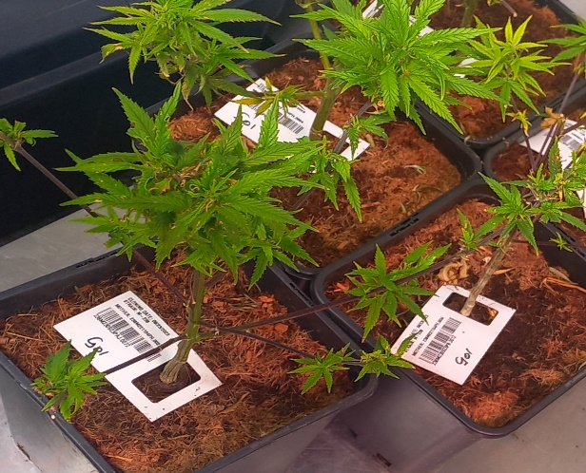 | 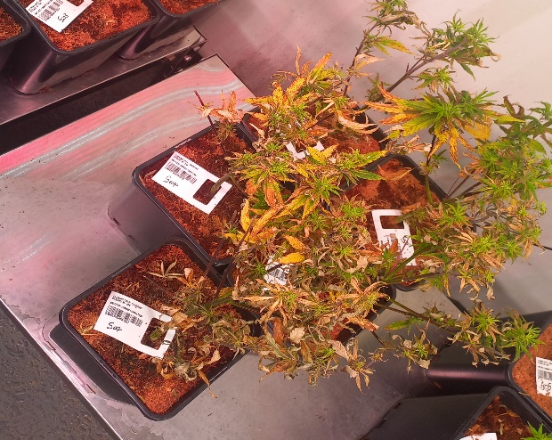
A. Without EDTA | B. With EDTA
Figure 4: Vegging Cannabis plants sprayed with PAA only and with PAA + EDTA.

  - Thermal Treatment
    - Treatment 1
In this treatment, a balancing act between killing pathogenic microorganisms and preserving the life of the treated plant had to be considered. Figure 5 below shows varying temperatures and different time intervals that the Cannabis flowering plants were subjected to.

42°C
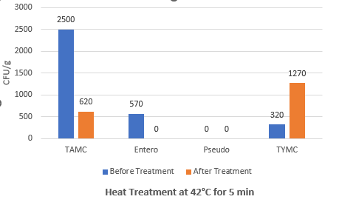 | 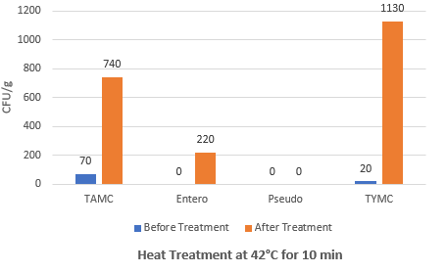
45°C
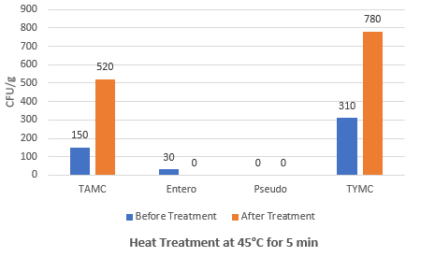 |  | 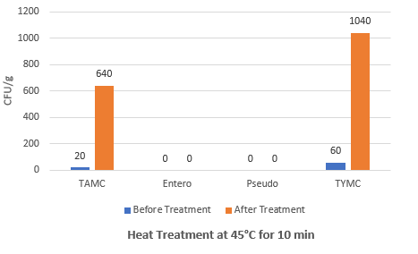
50°C
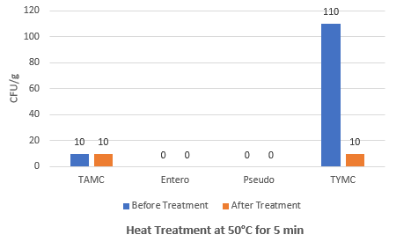 |  | 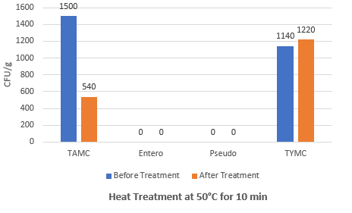
53°C
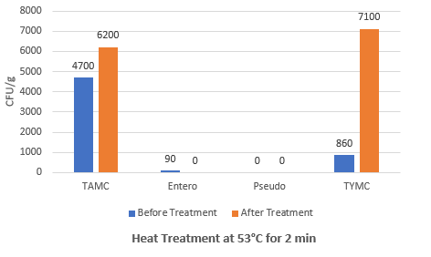 |  | 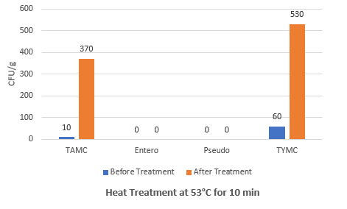
55°C
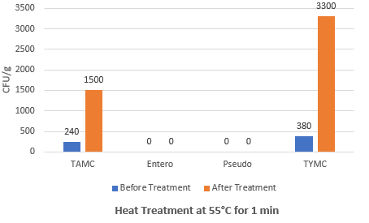 |  | 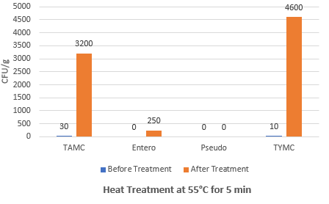
Figure 5: Heat Treatment (Oven/Dry heat method) of Cannabis Flos. at different temperatures with varying time intervals
In this preliminary heat treatment, most of the temperatures at which Cannabis plants were exposed did not kill or reduce microbial load but an increase in bioburden was rather observed depicted by high orange bars at almost all temperatures. This could be because of reasons that; dry heat used did not have enough contact time to penetrate the cell membrane and denature the nucleic acids (DNA/RNA) of present microorganisms and/or the dry heat temperatures were not high enough to achieve sterilization. Parija, (2012) claims that sterilisation by hot-air oven requires exposure to 160-180 °C for 2 hours and 30 minutes, which ensures thorough heating of the objects and destruction of spores. However, these parameters were impractical for this study as the objects of interest were living Cannabis plants.

    - Treatment 2
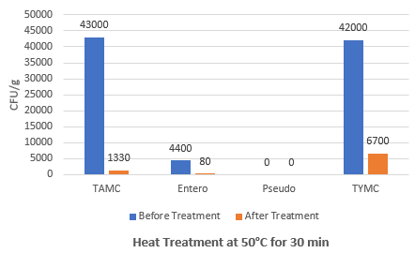 | 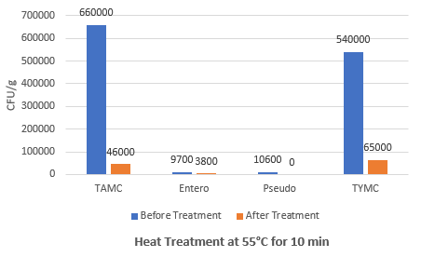
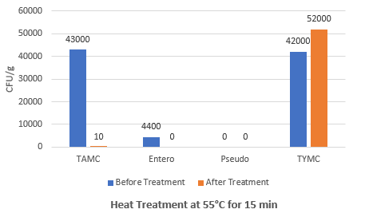 | 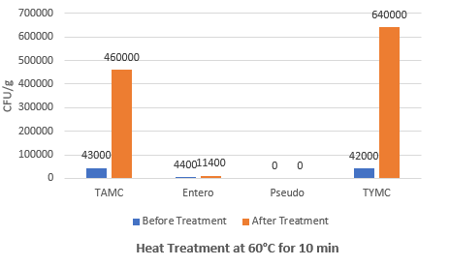
Figure 6: Heat Treatment of Treatment 1 Controls
Treatment 2 supported the known literature that extending contact time has the potential for dry heat temperatures to be effective against microbial contamination. As depicted in Figure 6, more of the orange bars can be seen to be lower than the blue bars which indicates a relative effectiveness of different temperatures at longer contact times especially 55 °C for 30 minutes. This however did not provide enough confidence to roll out dry heat treatment to the next phases of the study. Alternatively, moist heat treatments can be investigated for their possible effectiveness and efficiency in future studies.

  - Other Treatments
Treatment A: Oxisan fumigation of Pad 3, Room 5 (Refer to LuCan COAs: 515888 and 515889
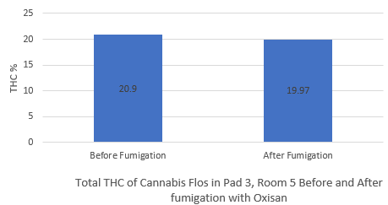 | 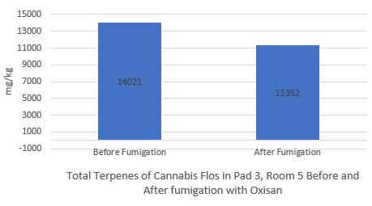
Figure 7: CN and TP of Cannabis Flos. Before and After Room 5 in Pad 3 was fumigated with Oxisan
The fumigation of Room 5 in Pad 3 resulted in a CN drop of 0.93 % and TP drop of 19.03 % (see Figure 7). These percentage decrease of both CN and TP can be disclosed as insignificant when compared with the potential outcome of the desired clean product.

Treatment B: Oxisan fumigation of L-612 (V-DL23002)
Table 14: Sensory testing by Inhouse Cannabis Sensory Expert (ICSE)
Organoleptic Properties | Result
Appearance | Pass
Aroma | Pass
Texture | Pass
Taste | Pass

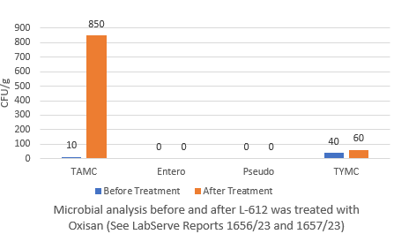
Figure 8: L-612 (V-DL23002) Microbial results
Although this treatment did not produce expected microbial results due to very low concentration of PAA used (0.05 % PAA) in gaseous form (Figure 8). The organoleptic properties were indistinguishable to that of the untreated Cannabis flower of the same batch.

- Conclusion
Chemical and Heat treatments of microbial bioburden were done on both Cannabis mother plants and Cannabis flowering plants and between the two treatments, Chemical treatment proved to be the most effective treatment, while within the chemical treatments, the use of Oxisan was the most effective even at the concentration as low as 0.15 %. Although the organoleptic properties were assessed on the Cannabis flower fogged with a very low concentration of Oxisan (0.05 %), there was no difference in organoleptic properties between treated and untreated Cannabis flower as per the ICSE. Cannabinoid concentration was relatively not affected while the Terpene profile was seen to reduce by 19 %. Heat Treatments were shown not to be effective at reducing microbial loads at the conditions tested.

- References

Choramo, A. (2022). A Review on Chemical and Physical Methods of Controlling Microbial Growth. HSOA Journal of Community Medicine and Public Health Care.
Gomez, N., Manetsberger, J., Benomar, N., Gutierrez, S., & Abriouel, H. (2022). Antibacterial and antibiofilm effects of essential oil components, EDTA and HLE disinfectant solution on Enterococcus, Pseudomonas and Staphylococcus sp. multiresistant strains isolated along the meat production chain. Frontiers in Microbiology, 1-20.
Hyesu, J., Hyeran, M., Hyo, K. J., Jeum, H. K., & Chang-Jin, P. (2019). effect of a peroxyacetic acid mixture as green chemical on rice bacterial and fungal pathogens. Journal of Plant Pathology, 661-669.
Margaret, H. (1972). Effects of EDTA and other compounds on chlorophyll breakdown in detached leaves. Phytochemistry, 2393-2402.
Organic Materials Review Institute (OMRI). (2000). Peracetic Acid. National Organic Standard Board (NOSB).
Parija, S. C. (2012). Microbiology and Imminology. Puducherry, India: Reed Elsevier India Private Limited.

